Your feelings about school - Primary
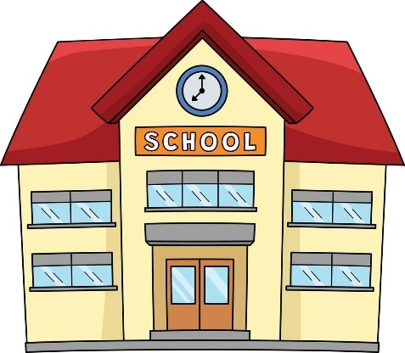
Look at a map of your school.
Colour in how the different parts of your school make you feel.
= I feel calm or relaxed in this space
= I feel worried/anxious in this space
= I never want to be in this space

For the areas coloured in green, what do you like about this space?

For the areas coloured in red, what makes you never want to be in this space?

How could the red spaces be made better for you?

The Social Environment - being around people and talking to people
When we are at school, there are lots of people to be around and to talk to. This can be adults and other children or young people. Sometimes we might feel alright with this, and at other times we might find this too difficult to deal with. How do you feel about the following:

I feel a little worried about this
I enjoy this
I am ok with this
I am very worried about this
I avoid this if I can

SOCIAL ASPECT | RATING | ADDITIONAL COMMENTS
Coming into school.
Being in the cloakroom to hang my coat or my bag.
Being in the classroom when the other children are moving around.
Knowing what I need to do when I come into the classroom.
Finding a place to sit.
Sitting on the carpet.
Lining up with my class.
Choosing times.
Going out to play.
Being in the dining hall/canteen with other children.
Getting changed for P.E.
Joining in with games, P.E., dance etc.

The Learning Environment – which lessons do you like and not like?
We have to learn about lots of different things when we are at school. Some things we enjoy learning about more than others. Some things we find harder than others. How do you feel about the following:
I enjoy this lesson
I am ok with this lesson
I feel a little bit worried about this lesson
I am very worried about this lesson
I avoid this lesson if I can
4
2
3
5
1
1

LESSON | RATING | YOUR COMMENTS  (Why that number?)
Reading | 1 2 3 4 5
Writing | 1 2 3 4 5
Spelling | 1 2 3 4 5
Maths | 1 2 3 4 5
Topic | 1 2 3 4 5
Science | 1 2 3 4 5
Computers | 1 2 3 4 5
Art | 1 2 3 4 5
Making things | 1 2 3 4 5
Dance | 1 2 3 4 5
Music | 1 2 3 4 5
P.E./Games | 1 2 3 4 5
R.E. | 1 2 3 4 5
Drama | 1 2 3 4 5
History | 1 2 3 4 5
Geography | 1 2 3 4 5
Other? | 1 2 3 4 5

Working in class
There are lots of different ways that we can work when we are at school. We might find some ways easier than others. How do you feel about the following:
I feel a little worried about this
I enjoy this
I am ok with this
I am very worried about this
I avoid this if I can

CLASS ASPECT | RATING | ADDITIONAL COMMENTS
Answering questions in class.
Listening to the teacher when they are explaining what we are going to do.
Following instructions – doing what we have been told to do.
Knowing what to do to start an activity.
Working on my own.
Working with someone else (a friend or learning partner).
Working in a group (with more than one person).
Asking a teacher for help when I do not understand something.
Working in a quiet space.
Working when other children are messing around.
Reading aloud in class.
Writing work down.
Recording what I have done in pictures.
Using a computer to record what I have done.
When the teacher is telling off other children.
When the teacher is marking my work.
When I go into class and there is a different teacher.
Making sure that I have everything I need for the lesson (e.g,. book, pencil case etc.)
When there is another adult (e.g., Teaching Assistant) helping me in class.
When I have to stop what I am doing before I am finished.
When the teacher uses pictures and videos to help explain things.
Doing homework.
Sharing equipment with others.
When other children try to distract me.
When I have to do a test at school.
What is your ideal classroom or lesson? What would make school better for you?

