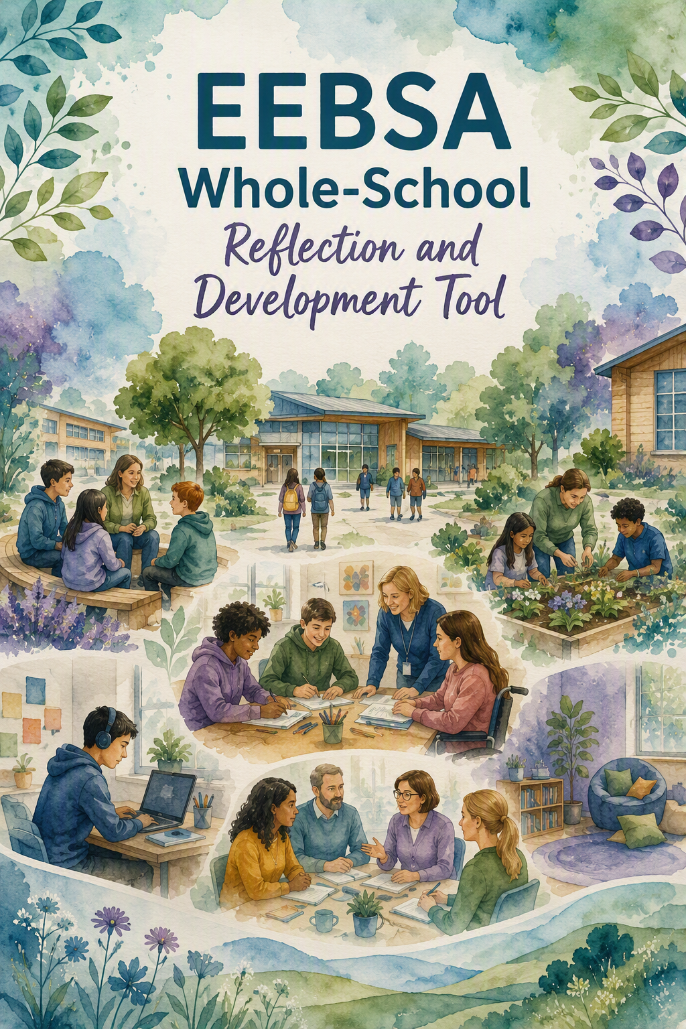
Using this tool
A concise guide for reflective discussion and practical development
Purpose
This tool supports schools and settings to reflect on how their culture, relationships, curriculum, environments and systems promote attendance, engagement, participation, wellbeing and belonging. It is intended to support dialogue and development, not inspection, accreditation or performance grading.

A flexible approach

• Use the whole tool for an in-depth review or select one section that matches a current priority.
• Involve a range of voices where possible, including leaders, teachers, support staff, governors, children and young people, and families.
• Draw on information gathered and lived experience rather than trying to reach a score.
• Focus on strengths, questions and one manageable development action in each area.
• Revisit the tool over time. Practice, context and the experiences of children and families will change.
Suggested discussion sequence

1. Notice | What do we see, hear and experience?
2. Listen | What do children, families and staff tell us?
3. Understand | What may be helping or creating barriers?
4. Act and review | What small change will we make, and how will we know whether it helps?
A note about language
EEBSA is used as a descriptive framework, not a diagnosis or fixed category. The questions in this tool are designed to help settings consider the interaction between children and young people, relationships, learning, environments, family circumstances and wider systems, while preserving dignity and avoiding blame.


1. Culture, Values and Belonging
Key principle
Children and young people are more likely to engage when they feel welcomed, valued, included and part of their school community.

What are we noticing?
• What messages do children, young people and families receive about attendance, participation and belonging?
• How do staff talk about attendance difficulties when concerns arise?
• When a pupil begins to struggle, do we take time to understand what may be happening before deciding what should change?
• How visible are inclusion, belonging, participation and wellbeing within our school priorities and everyday practice?
• Do children and young people experience our setting as welcoming, fair and respectful?
• If pupils were asked why school is worth attending, what might they say?
Questions to explore
• Are there differences between the values we describe and what some pupils or families experience?
• Which groups may feel less visible, less included or less connected?
• How do we communicate expectations in a way that maintains positive relationships?
What is informing our reflection?
☐Child and young person views | ☐Family feedback
☐Staff observations | ☐Attendance information
☐Participation and engagement information | ☐Wellbeing and belonging information
☐Other:

Current strengths
What we would like to understand better
One practical development action

Lead: | Review date:

2. Relationships and School Connectedness
Key principle
Strong, dependable relationships can protect attendance, engagement and wellbeing and help children reconnect when difficulties arise.

What are we noticing?
• Can pupils identify adults who know them well and are available when needed?
• How do we help children and young people develop a sense of connection and belonging?
• Which pupils may appear present but feel isolated or disconnected?
• How are friendships and positive peer relationships supported?
• What happens when relationships with adults or peers become strained?
• How do we help pupils reconnect following absence, transition or a difficult experience?
Questions to explore
• Do trusted relationships depend too heavily on one member of staff?
• How do we know whether pupils feel safe approaching adults?
• What opportunities exist for every pupil to contribute and experience success with others?
What is informing our reflection?
☐Child and young person views | ☐Family feedback
☐Staff observations | ☐Attendance information
☐Participation and engagement information | ☐Wellbeing and belonging information
☐Other:

Current strengths
What we would like to understand better
One practical development action

Lead: | Review date:

3. Participation, Engagement and Curriculum Access
Key principle
Physical presence does not always mean meaningful participation. Learning becomes more accessible when barriers are noticed and reduced.

What are we noticing?
• Which pupils appear engaged and able to participate meaningfully in learning?
• Which pupils attend but appear withdrawn, overwhelmed or disconnected?
• How accessible is the curriculum for pupils with literacy, communication, sensory or learning needs?
• How early are learning barriers identified and adjusted for?
• Do all pupils have regular opportunities to experience competence and success?
• How flexible are the ways pupils can demonstrate understanding and take part?
Questions to explore
• Are there subjects, tasks or routines that repeatedly create barriers for some pupils?
• Do we notice disengagement as early as we notice absence?
• How do staff respond when learning demands become difficult to access?
What is informing our reflection?
☐Child and young person views | ☐Family feedback
☐Staff observations | ☐Attendance information
☐Participation and engagement information | ☐Wellbeing and belonging information
☐Other:

Current strengths
What we would like to understand better
One practical development action

Lead: | Review date:

4. Environment and Accessibility
Key principle
The physical, sensory and social environment can either reduce or increase barriers to participation, connection and wellbeing.

What are we noticing?
• What is it like for pupils to arrive at and move through our setting?
• Which spaces and times of day appear welcoming, predictable and manageable?
• Which spaces or routines may feel noisy, crowded, uncertain or overwhelming?
• How are sensory needs considered in classrooms and shared spaces?
• How are transitions, unstructured times and unexpected changes supported?
• Do pupils know how to access a quieter or supportive space when needed?
Questions to explore
• What would pupils say about the sensory and social experience of a typical day?
• Are adjustments available consistently, or do they depend on a particular adult?
• Do supportive spaces help pupils regulate and reconnect, rather than becoming places of exclusion?
What is informing our reflection?
☐Child and young person views | ☐Family feedback
☐Staff observations | ☐Attendance information
☐Participation and engagement information | ☐Wellbeing and belonging information
☐Other:

Current strengths
What we would like to understand better
One practical development action

Lead: | Review date:

5. Children, Young People and Families as Partners
Key principle
Understanding develops through listening. Children, young people and families should influence decisions, not simply be informed of them.

What are we noticing?
• How do we gather and act on the views of children and young people?
• Are communication methods adapted for developmental and communication needs?
• How easy is it for families to share concerns before difficulties escalate?
• Do families experience conversations as respectful, useful and collaborative?
• How do we respond when children, families and staff understand the situation differently?
• How do we show that views have influenced decisions and support?
Questions to explore
• Whose voices are easiest for us to hear, and whose may be less visible?
• What practical, relational or communication barriers may make partnership difficult?
• If children and families described their experience of seeking help, what might they say?
What is informing our reflection?
☐Child and young person views | ☐Family feedback
☐Staff observations | ☐Attendance information
☐Participation and engagement information | ☐Wellbeing and belonging information
☐Other:

Current strengths
What we would like to understand better
One practical development action

Lead: | Review date:

6. Early Identification, Support and Reflective Practice
Key principle
Concerns are easier to address when they are noticed early, discussed openly and met with flexible, regularly reviewed support.

What are we noticing?
• How early do we notice changes in attendance, engagement, participation, wellbeing or belonging?
• What happens when a member of staff begins to notice that a child may be finding attendance, engagement, or participation difficult?
• Do staff know who to speak to and feel supported to respond?
• How do we bring together attendance information with pupil voice, family views and school-based evidence?
• How do we know whether support is making a positive difference?
• What opportunities do staff have to reflect, share learning and adapt practice?
Questions to explore
• Which early signs do we identify well, and which might we overlook?
• When support does not work as hoped, do we review the plan, the environment and our understanding rather than assuming a lack of motivation?
• How consistently are useful approaches shared across staff, classes and transitions?
What is informing our reflection?
☐Child and young person views | ☐Family feedback
☐Staff observations | ☐Attendance information
☐Participation and engagement information | ☐Wellbeing and belonging information
☐Other:

Current strengths
What we would like to understand better
One practical development action

Lead: | Review date:

Whole-School Reflection Summary
Bringing strengths, learning and priorities together
What are we most proud of?
What have children, young people and families helped us understand?
What are we still wondering about?
Our three priority areas for development:
1.
2.
3.
One manageable change we will make first
How will we know whether it is helping?

Action | Timescale | Review

