APPENDIX 4: GRADUATED RETURN AND RE-ENGAGEMENT PLAN
Turning shared understanding into coordinated, manageable and regularly reviewed action
Use this plan to carry forward the key information from Appendices 1 to 3. You do not need to repeat the full child, family or contextual narrative. The phases are not linear: support may draw on several phases at once, and any area can be revisited as circumstances change.

PLAN DETAILS

Child or young person: | School or setting:
Plan start date: | Review date:
Named contact: | People involved in developing the plan:

CURRENT AREAS OF FOCUS

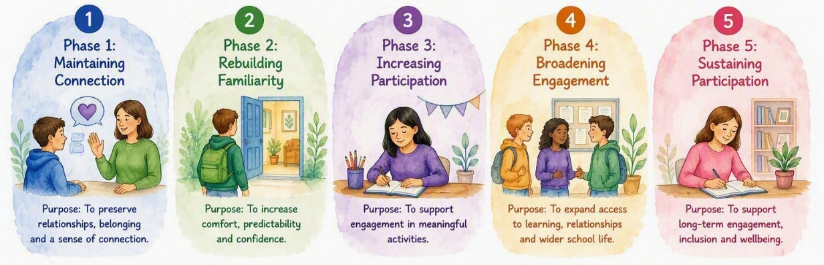

☐ Maintaining Connection | ☐ Rebuilding Familiarity | ☐ Increasing Participation
☐ Broadening Engagement | ☐ Sustaining Participation
Why have these areas been selected?
Refer to the child or young person’s current experience, priorities, capacity and the conditions that support engagement.

KEY INFORMATION TO CARRY FORWARD

Strengths, interests and protective factors
Child or young person’s priorities
Important relationships
Main barriers identified
Adjustments and support already helping
CURRENT RE-ENGAGEMENT PLAN
Plan meaningful opportunities, the support needed and what adults may notice
Meaningful opportunity or goal | Support and adjustments needed | When, where and who? | What might we notice? / Review date
What will the child or young person be supported to access, experience or participate in? | What will adults or the environment put in place to reduce barriers and enable access? | Day, time, location, arrival or transition arrangements, and who will help. | Observable signs of increased safety, connection, communication or participation. Add the review date.
Insert more rows as needed

Communication and contingency arrangements
How and when home and the setting will communicate | How the child or young person can show that something is becoming difficult
How adults will respond | What can be shortened, adapted, paused or revisited
Support that should remain available throughout | What happens if a key adult is unavailable
Who needs to know about the plan | Agreed way to ask for help, a pause or an early finish

REVIEW AND ADAPTATION
Treat changes and difficulties as useful information, not failure or regression
WHAT HAVE WE LEARNT?

What has become more manageable? | What remains difficult?
What has the child or young person communicated? | What has the family noticed?
What have staff or other professionals noticed? | Which adjustments and supports are helping?
What did not work as expected? | What might this tell us?

UPDATING THE PLAN

CONTINUE | PAUSE | CHANGE OR EXPLORE
Support, adjustments and opportunities that remain helpful | Opportunities that are not currently manageable or useful | Elements that need adapting or further understanding

The next manageable opportunity we will explore

Support and adjustments that need to be in place

The child or young person’s views about this

Next review date:

Named person co-ordinating the review:

