VC with Father and Mother Christmas

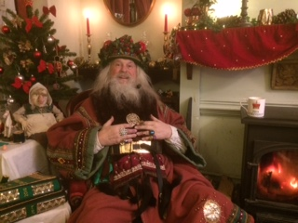7th, 8th, 9th, December 2021

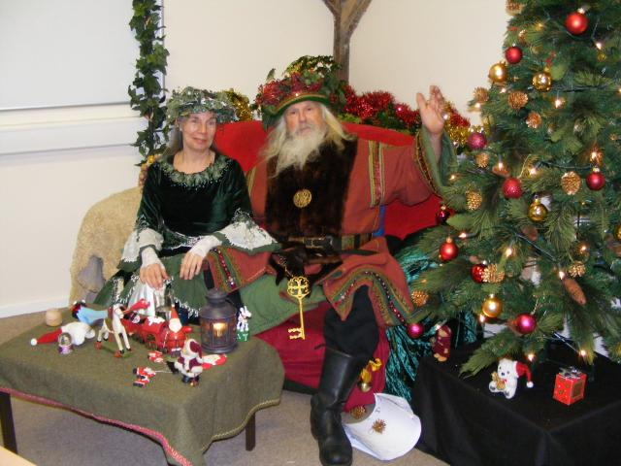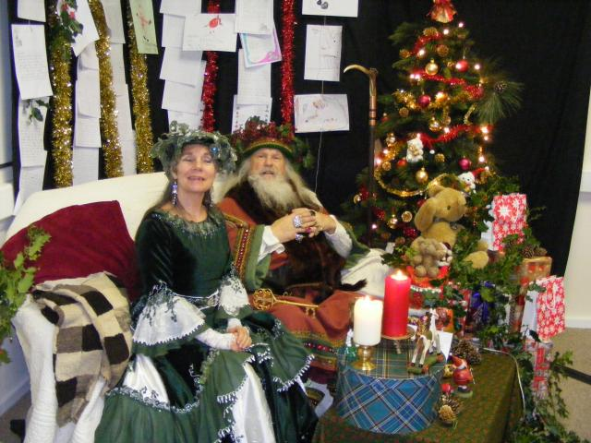

HAVE YOUR PUPILS BEEN GOOD THIS YEAR, IF SO WHY NOT TAKE PART IN THIS YEAR’S VC WITH FATHER AND MOTHER CHRISTMAS.

* TWENTY MINUTE SLOTS WITH 15 MINUTES TALKING WITH FATHER CHRISTMAS
* ALL YOU WILL NEED IS PC/LAPTOP WITH SPEAKERS, MICROPHONE AND WEBCAM.

(YOU MAY NEED TO DOWNLOAD A SOFTWARE CLIENT.)

* A TEST SESSION WILL BE CARRIED OUT WITH ONE OF THE E2BN OFFICE ELVES.
* £35 NET PER SESSION

FOR MORE INFORMATION OR TO BOOK YOUR SLOT PLEASE CONTACT US.

EMAIL: admin@e2bn.org PHONE NUMBER: 01462 834 588