Sensory investigation

Child/Young Person name:
Date of Birth & year group:
Practitioner Name & Role:

Sensory experience/ activity | 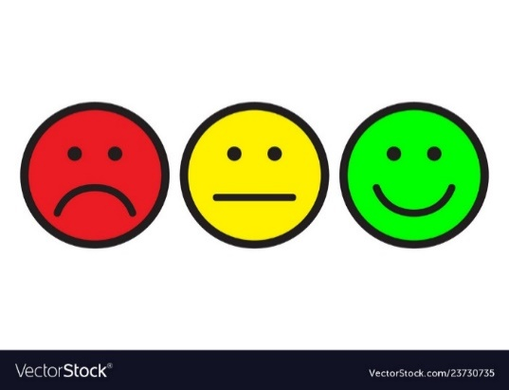  Response: |  |  | Alerting or calming:  

Sensory experience/ activity | Response: |  |  | Alerting or calming:

