|  |
| --- |
| **SEND Service 0-25 Years**  **Autism in Girls Checklist**  **For use in Primary Schools** |

|  |  |
| --- | --- |
| **Child/Young Person name:** |  |
| **Date of Birth & Year group:** |  |
| **School/Setting Name:** |  |
| **Name of person(s) completing checklist & role:** |  |
| **Date of completion:** |  |

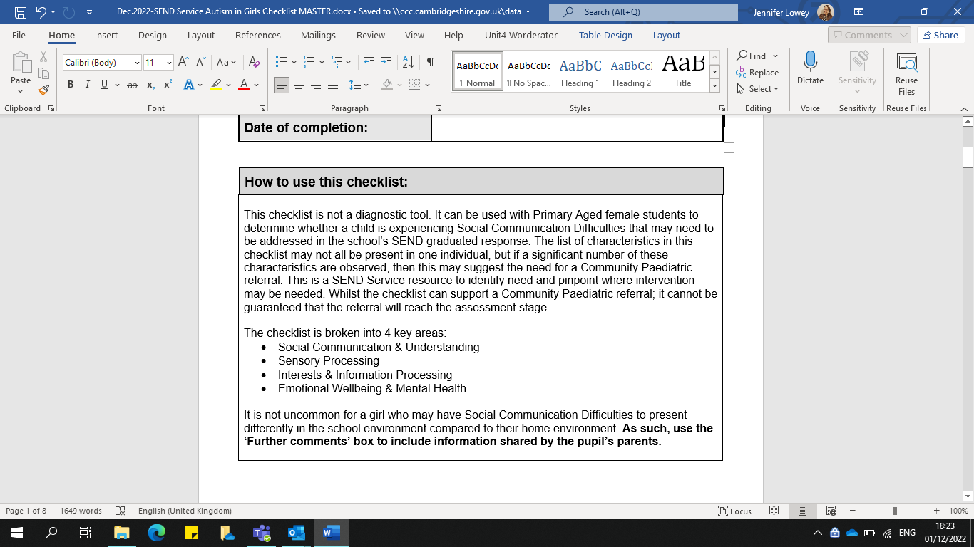

|  |  |  |  |  |
| --- | --- | --- | --- | --- |
| **Social Communication & Understanding:**  *Differences in understanding communication and language, jokes, sarcasm, tone of voice, facial expression, and gestures.*  *Differences in understanding social behaviour, understanding the feelings of others, how to start an informal conversation and forming friendships.*  To what extent are the following characteristics observed in the pupil at school? | Always | Often | Sometimes | Not observed |
| Expressive and articulate when discussing areas of interest. |  |  |  |  |
| Struggles to follow verbal instructions. |  |  |  |  |
| Demonstrates difficulties answering open questions. |  |  |  |  |
| Demonstrates a literal understanding of language *e.g., difficulties understanding metaphors or sarcasm* |  |  |  |  |
| Shows signs of situational mutism in certain situations or environments, despite talking at home. |  |  |  |  |
| Experiences difficulties initiating conversations or maintaining conversations. |  |  |  |  |
| Difficulties following another’s agenda in conversation *e.g., can talk eloquently about their own interests, but struggle to follow another person’s point of view* |  |  |  |  |
| Reluctance to answer questions in front of the class. |  |  |  |  |
| Difficulties with appropriate facial expressions and responses *e.g., her facial expression does not always match her mood or the situation* |  |  |  |  |
| Appears to have good expressive language skills or ‘mature’ language for their age. |  |  |  |  |
| Inability to understand jokes or makes jokes that others do not understand. |  |  |  |  |
| Presents themselves as an adult, *e.g., role playing being the teacher or interest in more mature activities, such as cooking, cleaning, construction, caring for younger children.* |  |  |  |  |
| Preference for playing or socialising with boys, over girls. |  |  |  |  |
| Lacks a close friend and appears on the periphery of a social group. |  |  |  |  |
| Or, has one or two intense friendships. |  |  |  |  |
| Appears to dominate other children during play or unstructured activities *e.g., wanting to control the rules during a playground game or unable to play another child’s game* |  |  |  |  |
| Or, appears shy and passive in social situations. |  |  |  |  |
| Does not want to be the centre of attention or have the spotlight on them. |  |  |  |  |
| Can form friendships, but experiences difficulties maintaining healthy friendships *e.g., frequent fallouts on the playground* |  |  |  |  |
| Preference of spending playtime with school staff, rather than peers. |  |  |  |  |
| Plays more successfully with younger children. |  |  |  |  |
| Takes longer to settle in a new situation or interact with unfamiliar people than her peers. |  |  |  |  |
| Struggles with group work, or shows a preference for working solo. |  |  |  |  |
| Experiences difficulties asking for help *e.g., will persevere with work they find difficult without asking a teacher for help* |  |  |  |  |
| Very loyal and trustworthy in friendships *e.g., will stick up for a friend in a peer conflict* |  |  |  |  |
| Appears very honest or finds it difficult to lie *e.g., commenting on a person’s appearance in a factual way* |  |  |  |  |
| Appears exhausted from trying hard to socialise or ‘blendin’* at school  *\*Blending: an attempt to fit in with others* |  |  |  |  |
| Strong sense of moral justice. |  |  |  |  |
| Finds it difficult to understand or accept another person’s viewpoint *e.g., becomes frustrated when someone disagrees with their opinion* |  |  |  |  |
| Struggles to understand the impact of their actions or comments on another person’s feelings *e.g., not understanding that a factual comment about someone’s appearance can be interpreted as rude* |  |  |  |  |
| Hypervigilant *e.g., acutely notices when a new or unfamiliar person enters the classroom* |  |  |  |  |
| Successfully observes and copies behaviour *e.g., using a learnt script when meeting new people, or copying peers to follow an instruction in class* |  |  |  |  |
| Possesses skilled observation skills. |  |  |  |  |
| Good at following the school rules. |  |  |  |  |
| Further comments: *(Inc. parents’ views)* | | | | |

|  |  |  |  |  |  |
| --- | --- | --- | --- | --- | --- |
| **Sensory Processing:**  *Differences in perceiving sensory information, hypo (low sensitivity), hyper (high sensitivity), touch, sight, hearing, smell, taste, vestibular (balance), proprioceptive (body awareness)*  To what extent are the following characteristics observed in the pupil at school? | | Always | Often | Sometimes | Not observed |
| Hyper (high) sensitivity: | Touch, *e.g., avoids standing close to others or is sensitive to certain shoes and clothing* |  |  |  |  |
| Sight, *e.g., sensitive to bright lights or squinting in the sunshine* |  |  |  |  |
| Hearing, *e.g., overly sensitive to specific sounds or noise or cannot focus within a noisy environment* |  |  |  |  |
| Smell, *e.g., dislikes the smells of specific foods* |  |  |  |  |
| Taste, *e.g., restrictive diet or sameness in school lunch* |  |  |  |  |
| Vestibular, *e.g., avoids movement, such as feet being off the ground or may easily experience motion sickness or dizziness* |  |  |  |  |
| Proprioceptive, *e.g., difficulties manipulating small objects* |  |  |  |  |
| Hypo (low) sensitivity: | Touch, *e.g., enjoys deep pressure activities or is attached to touching a certain toy to calm herself* |  |  |  |  |
| Sight, *e.g., attracted to flashing lights* |  |  |  |  |
| Hearing, *e.g., under reactive to loud or sudden noises or own name* |  |  |  |  |
| Smell, *e.g., does not notice or react to strong odours* |  |  |  |  |
| Taste, *e.g., prefers foods with strong flavours, such as spicy food* |  |  |  |  |
| Vestibular, *e.g., seeks movement involving rocking, swinging, or spinning without appearing dizzy* |  |  |  |  |
| Proprioceptive, *e.g., difficulties judging personal space and appearing clumsy* |  |  |  |  |
| Experiences sensory overload*  *\*Sensory overload: when one or more of the body’s senses experiences intolerable or excessive over-stimulation from the environment* | |  |  |  |  |
| Further comments: *(Inc. parents’ views)* | | | | | |

|  |  |  |  |  |  |  |
| --- | --- | --- | --- | --- | --- | --- |
| **Interests & Information Processing:**  *Differences in perception, planning, understanding concepts, generalising, and predicting, transitions and passions for interests.*  To what extent are the following characteristics observed in the pupil at school? | Always | | Often | | Sometimes | Not observed |
| Has intense interests that are specific and restricted. *These may be similar to most girls, e.g., books or animals, but more passionate* | |  | |  |  |  |
| Has a love of technology, animals, reading or friendships. | |  | |  |  |  |
| Identifies as an external or fictitious character, such as a character from a novel or TV show. | |  | |  |  |  |
| Has a particular subject strength or in-depth knowledge *e.g., in art or English or music* | |  | |  |  |  |
| Appears different to peers in terms of clothing *e.g., preference for wearing boys’ clothes or always wears the same clothes* | |  | |  |  |  |
| Imitates peers in style, dress, interests and manner (including speech). | |  | |  |  |  |
| Talks about a preferred topic or interest frequently and in a factual way. | |  | |  |  |  |
| Becomes lost in own thoughts and ‘checks out’ *e.g., staring into space and struggling to focus on another topic* | |  | |  |  |  |
| Difficulties starting work or stopping work that is unfinished. | |  | |  |  |  |
| Difficulties with change or transitions *e.g., experiencing anxiety when there is a change of staff or change to school routines* | |  | |  |  |  |
| Rigidity in daily routines or governed by time. | |  | |  |  |  |
| Engages in repetitive behaviours *e.g., tapping hands on desk or picking at their fingers, making repetitive comments, or asking repetitive questions* | |  | |  |  |  |
| Perfectionist, such as during work tasks *e.g., will become upset if a piece of work does not go the way they planned* | |  | |  |  |  |
| Described as a model student. | |  | |  |  |  |
| Fearful of failure or making mistakes *e.g., preventing them from even attempting a task or activity* | |  | |  |  |  |
| Difficulties processing lots of information at once *e.g., may need learning tasks to be presented one step at a time* | |  | |  |  |  |
| Becomes fixated on a mistake and appears unable to move past it. | |  | |  |  |  |
| Further comments: *(Inc. parents’ views)* | | | | | | |

|  |  |  |  |  |  |  |
| --- | --- | --- | --- | --- | --- | --- |
| **Emotional Wellbeing & Mental Health:**  To what extent are the following characteristics observed in the pupil at school? | Always | | Often | | Sometimes | Not observed |
| Presents physiological symptoms typical for anxiety *e.g., dizziness, feeling lightheaded, frequent urination, feeling cold or blushing or stomach aches* | |  | |  |  |  |
| Presents physiological symptoms typical for panic attacks *e.g., laboured breathing, sweaty or having chills, chest pains, sense of terror* | |  | |  |  |  |
| Experiences ‘meltdowns’ *e.g., outward signs of extreme distress such as crying, shouting, exiting the classroom* | |  | |  |  |  |
| Experiences ‘shutdowns’ *e.g., internalising distress becoming silent, withdrawn, and unable to communicate* | |  | |  |  |  |
| Meltdowns or shutdowns are reported to occur at home. | | Y: | |  | N: |  |
| Expresses or shows feelings of worry or anxiety *e.g., will ask lots of questions, seek reassurance, repeat information.* | |  | |  |  |  |
| Lacks certainty about gender, such as rejecting ‘feminine’ clothing or displaying a desire to present as male. | |  | |  |  |  |
| ‘Masks’ anxiety/ difficulties in one environment (i.e., school) and then appears to not cope in another environment (i.e., home)  *Masking = the ability to hide or hold in your anxiety so you appear calm | |  | |  |  |  |
| Appears compliant and passive in school, but can demonstrate difficult behaviours at home. | |  | |  |  |  |
| Further comments: *(Inc. parents’ views)* | | | | | | |

|  |
| --- |
| **References:** |
| * Carpenter, B., **Happé, F. & Egerton, J. (Eds.), (2019)** *Girls and Autism: Education, Family and Personal Perspectives*. London & New York: Routledge * Loomes, R. et al., (2017) ‘What is the Male-to-Female Ratio in Autism Spectrum Disorder? A Systematic Review & Meta-Analysis’, *Journal of the American Academy of Child & Adolescent Psychiatry,* 56(6), pp. 466-474 * NASEN, Carpenter, B. & Egerton, J. (2016), *Girls and Autism: Flying under the radar’*. Available at: <https://www.nasbtt.org.uk/wp-content/uploads/2020/07/flying-under-the-radar-miniguide-autism.pdf> (Accessed: 19 March 2021) * National Autistic Society, *Autistic women and girls*. Available at: <https://www.autism.org.uk/advice-and-guidance/what-is-autism/autistic-women-and-girls> (Accessed: 19 March 2021) * National Autistic Society, *Women and girls online training module*. Available at: <https://www.autism.org.uk/what-we-do/professional-development/training-and-conferences/online/women-and-girls> (Accessed: 19 March 2021) * Staffordshire County Council, *Autism in Girls Checklist.* Available at:  <https://www.staffordshire.gov.uk/Education/Access-to-learning/Graduated-response-toolkit/School-toolkit/Communication-and-interaction/Social-communication-autism/SEN-support-in-school/Autism-in-Girls-checklist.pdf> (Accessed: 19 March 2021) * The students of Limpsfield Grange School & Martin, V., (2015) *M is for Autism.* London & Philadelphia: Jessica Kingsley Publishers |