What you will need to do Expanded Rehearsal Technique (ERT) with your child

- The instructions for how to find out what your child already knows.
- The instructions on how to carry out an ERT session.
- Two plastic pots, one is for words your child can read easily and quickly. We will call this their ‘Forever Pot’ (because they will know that word forever and will not forget it tomorrow or next week).
The other pot is for the small number of sounds or words you will be working on with your child that week. You can call that the ‘working on’ pot. Some children will only have two or three sounds or words in this pot, others may have a few more. You must not try and learn too many in one week.

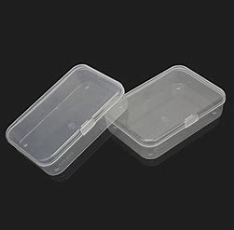

- A pack of the sounds and words cut up from the sheets in your pack. Do not cut out all the flashcards at once start with a few in the order of the sheets we have given you.

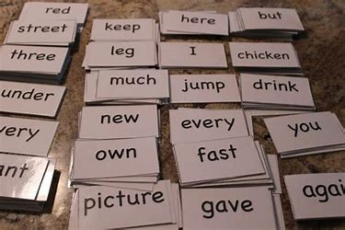

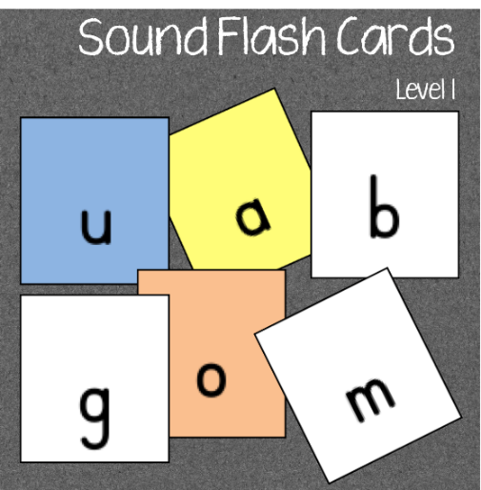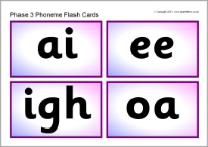

Finding Known Words

To find out sounds and words your child already knows correctly and quickly you will need the lists on pages 5 to 29 and a stopwatch.

The timer on a mobile phone is perfect. If you go into the clock on your mobile, you should be able to pick the stopwatch or timer option.

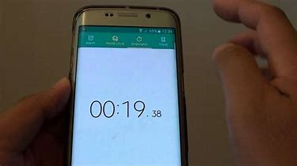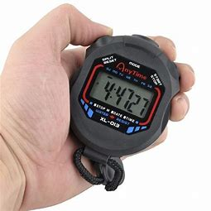

If you are unsure how the letters should sound, here is a clear YouTube video. Or just search with ‘English phonic sounds.

https://www.youtube.com/watch?v=-ksblMiliA8

Finding known words

Start with initial sounds (Pages 5 to 7). Give your child a couple of seconds for each sound.
- If they do not know it,
- say it incorrectly or
- take too long
do not worry tell them what it is, put a little dot in the Working on the column and go on to the next sound. If they know it but are slow just make a little dash ( - ) in the ‘working on column’ and leave them out of their Forever Pot later.

If they know them and can recall them quickly put a tick in the ‘knows’ column and put the cards with those sounds or words into their ‘Forever Pot’ at the end when you have finished. The others they do not know can be used for their Working on pot.

At this stage, it is best to do about 10 cards at a time. Your child should aim at 1 ½seconds per sound or word.
That is 15 seconds for 10 sounds.
If your child does not know any initial sounds or only four or five. STOP. Do not go on to words because this means they need to do more work getting to know these sounds first before moving on to sounds that use two or more letters or words. You can use the ERT teaching method to help them learn these but there are also many fun games and activities for helping your child learn these sounds that can be used as well as ERT. There are many fun activities which do not cost any money. Some of these are listed at the end of the pack or you can find them online or find through the BBC website.

Start the clock. Show these letters to your child, remember you want them to say the sound the letter makes not the letter’s name. It is helpful just to put a plain piece of paper or card over the sounds and move it down as your child says them.
Start the clock | Knows | Working On
b
c
d
f
g
h
j
k
l
m
Initial Sounds
Stop the clock.

How long to read and say these 10 sounds?
Remember the aim is 15 seconds

Start the clock | Knows | Working On
n
p
q
r
s
t
v
w
x
y
Stop the clock

How long to read and say these 10 sounds
Remember the aim is 15 seconds.

Start the clock | Knows | Working On
z
a
e
i
o
u
a…e ( as in make)
e…e ( as in eve)
i…e (as in life)
o…e (as in code)
u…e (as in mute)
Stop the clock

How long to read and say these 11 sounds?

Remember the aim is 17 seconds.

All these 31 sounds should take 47 seconds for your child to say if they are confident.
Now go onto the sounds that have two letters but make only one sound. Many children and even adults find these difficult, but your child may know a few and surprise you!
Some of these two-letter sounds can also make another sound, it depends on the word. One sound can also be made in different ways.
Look at these words the long ‘o’ sound is made in many ways.
open boat bone toe sow dough beau brooch sew 
Accept whatever your child says if it is one of the ways it can sound in a word but remind them later it can make other sounds as well.
They do not have to know all these before they can go on to learn words. If they do find these difficult, go onto words as they may be better at reading whole words.
If you are unsure of how these two or three-letter sounds should sound think of words that have these sounds in them: wait, hair, car, taut, raw, day, beat, hear, and deep. blew
Start the clock | Knows | Working On
ai
air
ar
au
aw
ay
ea
ear
ee
ew
Stop the clock

How long to read and say these 10 sounds?

Remember the aim is 15 seconds.

If you are unsure of how these complex phonemes should sound think of words that have these sounds in them: runner, prey, high, bird, boat, boil, book, door, short, round
Start the clock | Knows | Working On
er
ey
igh
ir
oa
oi
oo
oor
or
ou
Stop the clock

How long to read and say these 10 sounds?

Remember the aim is 15 seconds.

If you are unsure of how these complex phonemes should sound think of words that have these sounds in them: boy, church, chop, back, knife, photo, quick, shop, thing, why
Start the clock | Knows | Working On
oy
ur
ch
ck
kn
ph
qu
sh
th
wh
Stop the clock

How long to read and say these 10 sounds?

Remember the aim is 15 seconds.

Now we move on to words.
It does not matter if your child must sound out each phoneme and then put them together to say the word. They are taught to do this if they are stuck on a word, but it does not work with some words (was, two, ice).
Give your child about 3 seconds to say the word and then reassure them that it is ok if they cannot work it out yet and move on. Put a dot in the working column if they do not know the word but add 3 seconds to their time for each unknown word. Put a dash ( - ) if they read it slowly by sounding out each phoneme this will show in how long they take to read the group of words to you.
When we read, we want to read fluently so we can understand more easily what the words are telling us. Therefore, in ERT we ask children to read against the clock. The aim is to help a child read more fluently so they can understand more.
Finding out what your child knows quickly can take a while so stop when your child is struggling or showing signs of getting tired, cross, or upset you should have found enough words and sounds for their ‘Forever Pot’ and some you can put in the ‘Working On’ pot. You can always go back when they can say those words or words quickly and see what they know in the next word section to give you more to put in the different pots.

High Frequency Words: Set 1

Start the clock | Knows | Sounds out/ Working On
a
about
after
all
am
an
and
are
as
at
Stop the clock

How long to read and say these 10 words?
Remember the aim for this is 15 seconds.

High Frequency Words: Set 2

Start the clock | Knows | Sounds out/ Working On
away
back
be
because
big
but
by
call
came
can
Stop the clock

How long to read and say these 10 words?
Remember the aim for this is 15 seconds.

High Frequency Words: Set 3

Start the clock | Knows | Sounds out/ Working On
come
could
did
do
down
for
from
get
Stop the clock

How long to read and say these 8 words?
Remember the aim for this is 12 seconds.

High Frequency Words: Set 4

Start the clock | Knows | Sounds out/ Working On
had
has
have
he
her
here
him
his
I
in
Stop the clock

How long to read and say these 10 words?
Remember the aim for this is 15 seconds.

Three or more letters’ Words: Set 5
(Some of these words cannot be sounded out)

Start the clock | Knows | Sounds out/ Working On
into
is
it
last
like
little
live
look
made
make
Stop the clock

How long to read and say these 10 words?
Remember the aim for this is 15 seconds.

High Frequency Words: Set 6

Start the clock | Knows | Sounds out/ Working On
me
my
new
next
not
now
of
off
old
on
Stop the clock

How long to read and say these 10 words?
Remember the aim for this is 15 seconds.

High Frequency Words: Set 7

Start the clock | Knows | Sounds out/ Working On
once
one
other
our
out
over
put
said
saw
see
Stop the clock

How long to read and say these 10 words?
Remember the aim for this is 15 seconds.

High Frequency Words: Set 8
Start the clock | Knows | Sounds out/ Working On
she
so
some
take
that
the
their
them

Stop the clock

How long to read these 8 words

Aim at 12 seconds

High Frequency Words: Set 9

Start the clock | Knows | Sounds out/ Working On
they
this
three
time
to
today
too
two
up
us
Stop the clock
How long to read these 10 words

Aim at 15 seconds

High Frequency Words: Set 10
Start the clock | Knows | Sounds out/ Working On
very
was
we
went
were
what
when
will
with
you

Stop the clock

How long to read these 10 words
Aim at 15 seconds

How to Teach your Child a Sound or Word the ERT way

This stage and beat the clock should take about 10 minutes. It should be done 3 times a day if possible. If you cannot manage that once or twice a day is ok.

Now you have found out some of the sounds and words your child knows and can say quickly and some they do not know or are slow at recognising or sounding out.

Use the pack of sounds and words enclosed and cut out all those words and sounds your child knows and put them in the Forever Pot.
Cut out just a few (four or five) of the sounds and words they do not know or are slow at recognising and put them in the Working on Pot.
It helps if the words and sounds are printed onto the card as cards help them ‘survive’ a little better because they will all be used a lot. If you do not have a card just cut up the ones in the pack.

Remember to work through learning the words and sounds in the order of the sections already sorted out for you. Unknown two or three-lettered words can be added very gradually to your Working on Pot as you work through unknown words.
Here is the order listed below.
- Initial sounds
- One sound using two or more letters
- High Frequency word in 10 sets

It helps if you work through the word sets in order
- Pick one unknown word or sound out of the Working on Pot for example about in Set 1
then
- four known words or sounds from the ‘Forever pot.’
Try and use the most recent words or sounds they have learnt at this stage from your Forever pot
- Show the unknown word or sound to your child and say it to them
‘This word says about. Your turn, what does this word say?’

about

- If your child says about, f praise then pick up one of the known words or sounds you have chosen and place it over the sound or word they are working on.
- Ask them what this card says for instance it could be

am

- If they say it correctly uncover the word you are working on ‘about’ and ask them what it says, if they remember it, lots of praise. If they cannot remember tell them what it says and ask them to say it again.
- Choose another known word or sound and cover the two cards you now have on the table or in your hand.
- Ask them what it says then uncover am and ask what that says and finally uncover the word you are working on ‘about.’ And ask them what that word is. At any time if they get it wrong just tell them and ask them to repeat it after you.
- Cover up these three cards with another known card
And ask them what it says if they say it correctly, uncover and the cards underneath one by one asking them to say what is on the card, the last card is always the one they are working on.
- Continue like this so you have gone through all four known cards and the card you are working on.
5 4 3 2 1

about

am

and

are

sh

Reading order by the end →

Speed or Fluency
This stage is to help your child begin to read more fluently. This is where the timer comes in. Most children like this stage as it feels like a game to them. So, make it upbeat and fun. Some children like a special book to record their times in and hopefully, they will see themselves getting faster. It is nice to tell them 10 words in 15 seconds is a decent adult speed and that is what you are aiming for. One and half seconds per card is the speed you want to aim for.

You now have 5 words, four from the Forever pot and 1 from the working on pot. If your child has struggled with these five words use just these words and time those.

If your child was ok reading them, choose five more from the Forever pot. Put in four recent words and choose one from sessions a while back. You can mix words and sounds as this helps your child feel more confident if they can switch between the two. It also helps your child go back and recall what they have learnt. The rule is that the more often you do something the easier it will be to remember it. This sounds like common sense, and it is as research has proved it!
Beat the Clock

Put out the cards you have chosen in a line with the word or sound you have been working on today as the last card. Tell them you want them to read all the cards as fast as they can. Start the timer and move your finger along the line of words from left to right (the direction we read in). You can lay them out in two lines of five so they get into the habit of reading the way you would a book. Left →Right, back to beginning and Left →Right again. Some young children find that hard.

If they cannot recall a word or seem to be taking too long just pick that card up, tell them what it is and move on. Write their time down or ask them to write it down. Words they missed or have forgotten should be used in the next session to help ‘bed’ them in more firmly.

Always use lots of praise and if they feel sad that they messed up let them have another go or say they will be super good next time. Unfamiliar words or sounds that your child reads correctly over three days you can put in their Forever pot. It is surprising how much a child can forget after one, two or three ‘sleeps.
At the end of a week learning some new sounds or words, they can have a go at a massive beat-the-clock. Spread all the words from the forever pot on the table and see if they can remember them all and how long it takes them to read them. Only try that if your child is confident about having a go at it.
If they are not just ask them to dip into the forever pot and pull out some words to time.

Remember we are aiming at a child with this face


Not this one.


Flashcards to cut out
Single letter sounds
b | c
d | f
g | h
j | k
l | m
n | p

q | r
s | t
v | w
x | y
z | a
e | i
o | u

Here the child should say the letter name not the sound
a_e | make
e_e | eve
i_e | life
o_e | code
u_e | mute

Two or three letters but one sound
ai | air
ar | au
ay | ea
ear | ee
ew | er
ey | igh

ir | oa
oi | oo
oor | or
ou | oy
ur | ch
ck | kn

ph | qu
sh | th
wh

  - High-Frequency words
a | about
after | all
am | an
and | are
as | at
Aim rate – 15 seconds per 10 words

away | back
be | because
big | but
by | call
came | can
come | could
did | do
down | for
from | get
go | got

had | has
have | he
her | here
him | his
I | in
into | is
it | last
like | little
live | look
made | make

me | my
new | next
not | now
of | off
old | on
once | one
other | our
out | over
put | said
saw | see

she | so
some | take
that | the
their | them
then | there
they | this
three | time
to | today
too | two
up | us

very | was
we | went
were | what
when | will
with | you

Some Useful Resources and Tips
- Cam bugs for the iPad and iPhone. This helps them practice sounds and words at speed and then they can earn a little bug for their collection. The cheap app unfortunately cannot be used on android devices. It is for the iPad and iPhone only
- If your child initially sounds hard try finding things in an old catalogue and cutting them out (Argos catalogues are great if you have an old one lying around). Get a big sheet of paper, leftover wallpaper is good, and mark out sections for different letter sounds in the alphabet (always say the sounds not the letter name) and stick the pictures under the right sound. Washing machine under w, doll under d, tent under t. This can occupy a child for a long time as you can find pictures in comics, magazines etc. Extra points for anyone who find a zebra for z and something for x!
- Play I spy with sounds and for older children, you might find something that has a two or three-letter sound in it for instance. I spy with my little eye something that has the sound or in it…horse or has the sound ow in it …cow.

