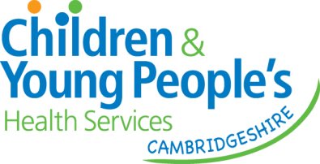

1.4.2025

Dear Education Colleague,

Following a reduction in funding from Cambridgeshire County Council and other efficiency savings within health, we have re-designed parts of our service to reflect the new budget arrangements.

Please see our updated Guide for Referrers <https://www.cambspborochildrenshealth.nhs.uk/services/cambridgeshire-childrens-occupational-therapy-service/>

1. Children with complex physical needs to continue to be referred into our service reflecting need to support function and participation.
2. Referrals for mainstream primary age children where the emphasis is on dysregulation in school will be offered school training to promote a whole classroom/whole school approach. <https://www.cambspborochildrenshealth.nhs.uk/services/cambridgeshire-childrens-occupational-therapy-service/online-learning-and-training/helping-children-to-be-ready-to-learn/>
3. Other reasons for referral for children attending mainstream school, related to accessing the curriculum will be triaged for a conversation with the Referrer. Evidence must be provided as to utilisation of universal and targeted support.
4. Referrals for mainstream primary age children for challenges with activities of daily living, centred around the home - will be triaged for a telephone consultation/video conference call with the parent/carer. Evidence must be provided as to utilisation of universal and targeted support.
5. Early Years - if evidence for universal and/or targeted level of support been tried/is in place and further support needed from our service, these children will be seen for individual assessment and intervention as indicated to support a specific goal(s).
6. Secondary Age – if evidence for universal and/or targeted level of support has been tried/is in place and further support needed from our service, these children will be seen for individual assessment and discharged following the assessment.
7. Our Advice Line (available for parents/carers/education staff) will be increasing to include a facility for a call back if the call is missed. <https://www.cambspborochildrenshealth.nhs.uk/services/cambridgeshire-childrens-occupational-therapy-service/advice-line/>

With kind regards, Nicola Foreman, Clinical Lead for Children’s Occupational Therapy