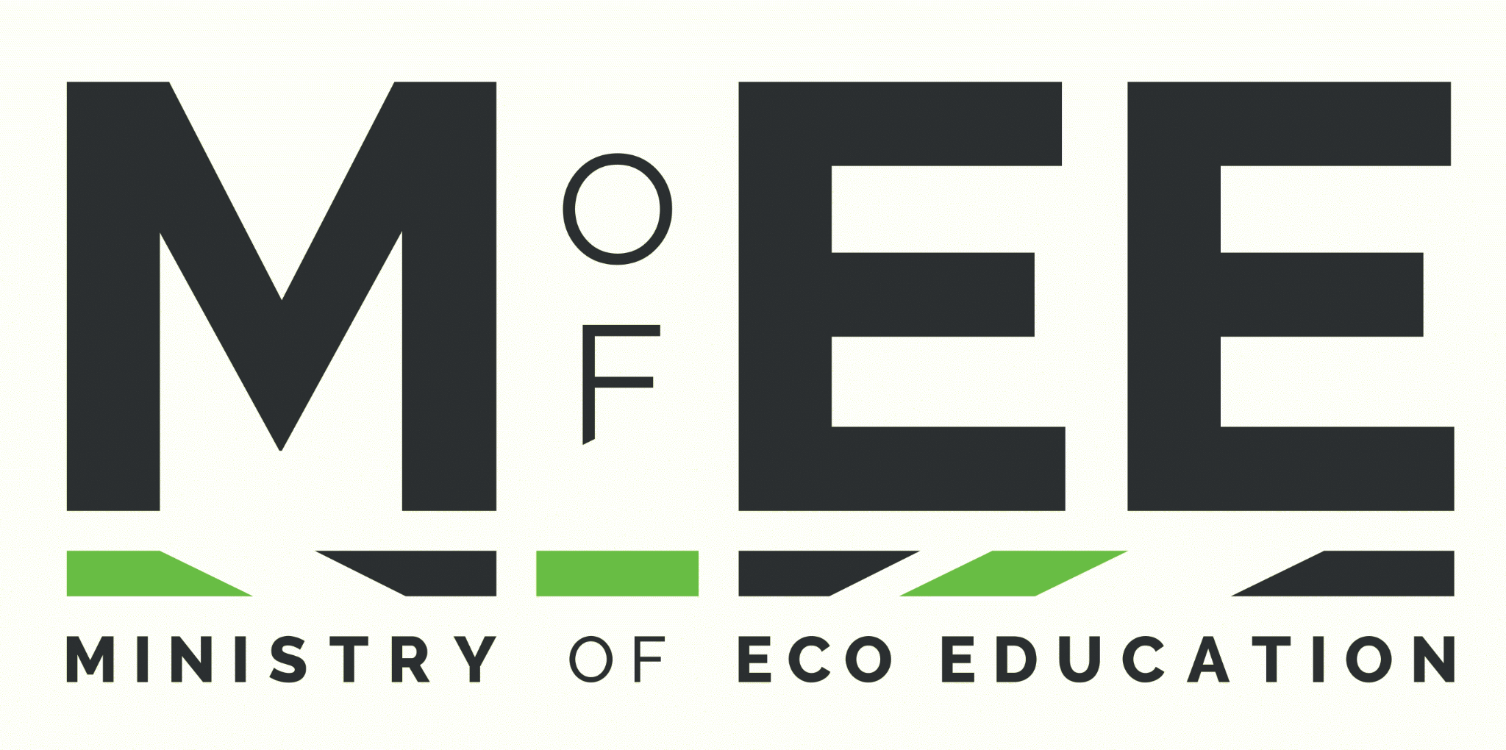 | 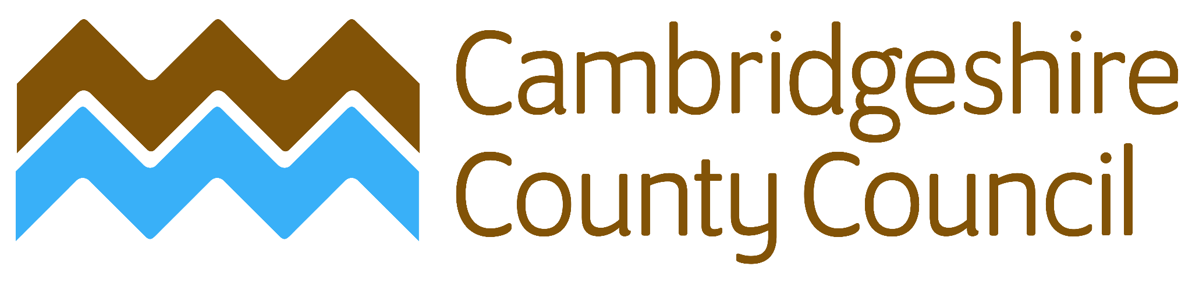

Cambridgeshire is made up of 5 districts in the East of England, representing 60 divisions. In total Cambridgeshire has a population of more than 800,000 people, living in both urban and rural areas. There are 246 primary schools and 83 secondary schools. Cambridgeshire County Council aims to be net-zero by 2030, and is supporting the wider county to become net-zero by 2045.
https://www.cambridgeshire.gov.uk/

The Ministry of Eco Education is a charity supporting schools to embed sustainability across their existing curriculum. We have woven together free resources from 100s of organisations and are engaged with more than 3,000 schools across the country.
https://www.ministryofeco.org/

Education for Sustainability enables young people to develop the knowledge, values and skills to participate in decisions about the way we do things individually and collectively, both locally and globally, that will improve the quality of life now without damaging the planet for the future.

MEE Big Questions | Cambridgeshire Examples
Energy  - What is really renewable?  - What does it take to make a cup of tea?  - Is carbon a magic ingredient?  - How should we heat our homes?  - How green is the internet?  - Can gas be green?  - Is the future electric?  - Do we need to insulate our homes?  - Is community energy the answer? | Solar Together Cambridgeshire https://solartogether.co.uk/cambridgeshire/home
Transport  - How can we travel the world?  - How can we make places more liveable?  - Can we all fly?  - Should everyone get an electric car?  - Should public transport be free?  - Should cars be banned from the school gate?  - Should we walk more? | EV Charging Map  https://www.zap-map.com/live/  Cambridgeshire Cycling routes  https://www.cambridgeshire.gov.uk/residents/travel-roads-and-parking/cycling/cycle-routes-and-maps
Food  - Where should we get our food?  - Should we all go vegan?  - What happens to food waste?  - Is the future community farms? | CoFarm and Cambridge Sustainable Food  https://ffcc.co.uk/cambridgeshire
Nature  - How does your garden grow?  - Who lives in the woods?  - Is the climate breaking down?  - How important is soil?  - Who lives near me?  - Where have all the trees gone?  - How does nature grow?  - Does it matter if species go extinct?  - Is nature the answer?  - Is the weather changing?  - How should we use land?  - Where are the lost words?  - What is a just transition?  - Do we need more rewilding? | Wildlife Trust for Beds, Cambs and Northants  https://www.wildlifebcn.org/nature-reserves/cambridgeshire-nature-reserves  The Great Fen  https://www.greatfen.org.uk/about-great-fen/heritage/brief-history-great-fen  Huntingdonshire District Council Biodiversity Community Grants  https://www.huntingdonshire.gov.uk/news/huntingdonshire-district-council-launches-community-grant-to-boost-biodiversity/
Society  - What is a community?  - Who is in charge?  - Who does the Earth belong to?  - Is the future already written?  - What is net zero?  - What is climate justice?  - How many people is too many?  - Do we need a metaverse?  - Does it matter where we put our money?  - Does it matter how we spend our money?  - Should ecocide be law?  - How important is play?  - Do people in other countries matter?  - Should every job be a green job?  - Is the climate crisis our greatest experiment?  - Should the rich pay for climate change?  - How sustainable is the UK? | CCC is harnessing the power of local communities to develop place-based sustainability  https://www.cambridgeshire.gov.uk/asset-library/part-1-climate-change-and-environment-strategy-2022.pdf  Net Zero Carbon Buildings  https://consultations.greatercambridgeplanning.org/greater-cambridge-local-plan-first-proposals/explore-theme/climate-change/policy-ccnz-net-zero
Waste  - Who made my clothes?  - How much stuff is enough?  - Does anything ever go away?  - Do we live on a plastic planet?  - Why does sewage end up in rivers? | Plastic Recycling Cambridgeshire  https://www.plasticexpert.co.uk/plastic-recycling-cambridgeshire/  Tackling waste in rivers  https://theriverstrust.org/about-us/news/new-great-ouse-rivers-trust
Water  - What is in the ocean?  - Do we live on a blue planet?  - Will we run out of water?  - Why are our rivers polluted?  - Why is all the ice disappearing?  - How important is blue carbon?  - How can we protect the ocean? | Walking in Water  https://www.youtube.com/watch?v=H9tGIFnk74I  https://www.friendsofthecam.org/content/walking-water  History of the Great Fen, incl. Flooding and restoration  https://www.greatfen.org.uk/about-great-fen/heritage/brief-history-great-fen  Rivers  http://www.cambsgeology.org/camvalley  https://theriverstrust.org/key-issues/state-of-our-rivers

