0-19 Healthy Child Programme, Cambridgeshire and Peterborough

Oak Tree Centre

Oak Drive

Huntingdon

PE29 7HN

Call our team on: **0300 029 50 50**

**Email us at:** [**cambs.pboro.childrenshealth@nhs.net**](mailto:cambs.pboro.childrenshealth@nhs.net)

Message us on**: #Textus 07520649887 (parents only)**

Dear colleague,

We are contacting you from the 0-19 Healthy Child Programme in Cambridgeshire and Peterborough, to give you an update on your local School Nursing offer.

Over the summer we have made some changes to our service which may impact the advice and information you give to children, young people and families.

We have made these changes to prioritise in-person work with children, young people and families which focuses on early intervention and health literacy.

Importantly, we are no longer using the Chathealth text messaging platform for access to our service, as evaluation showed it had low uptake and awareness amongst our young people (as demonstrated through audit and co-production activities).

We have a range of information, resources, and signposting at our website, with sections for both parents and professionals <https://portal.cambspborocyphs.nhs.uk/> and young people aged 11-19 <https://bit.ly/3AXJ2h4>

We offer health evaluation and self-care advice, through our Getting Ready for Change Questionnaire (GR4C) <https://portal.cambspborocyphs.nhs.uk/> which is circulated at key transition points.

We also offer, targeted 1:1 support for health-related topics such as; health concerns, healthy lifestyle advice, healthy bladder and bowel support, healthy relationships and support with transition, our electronic referral form can be completed here: <https://bit.ly/3NNHpWt>

**Please no longer promote Chathealth and remove this information from your signposting. Any residual promotional materials can now be discarded, as this service is no longer operational in our area. Alternative providers are detailed below which can be shared with families.**

Yours Sincerely,

The Healthy Child Programme team.

The School Nursing service duty desk can be contacted on 0300 029 5050 or further resources can be accessed via our young persons’ webpages: <https://bit.ly/3AXJ2h4>

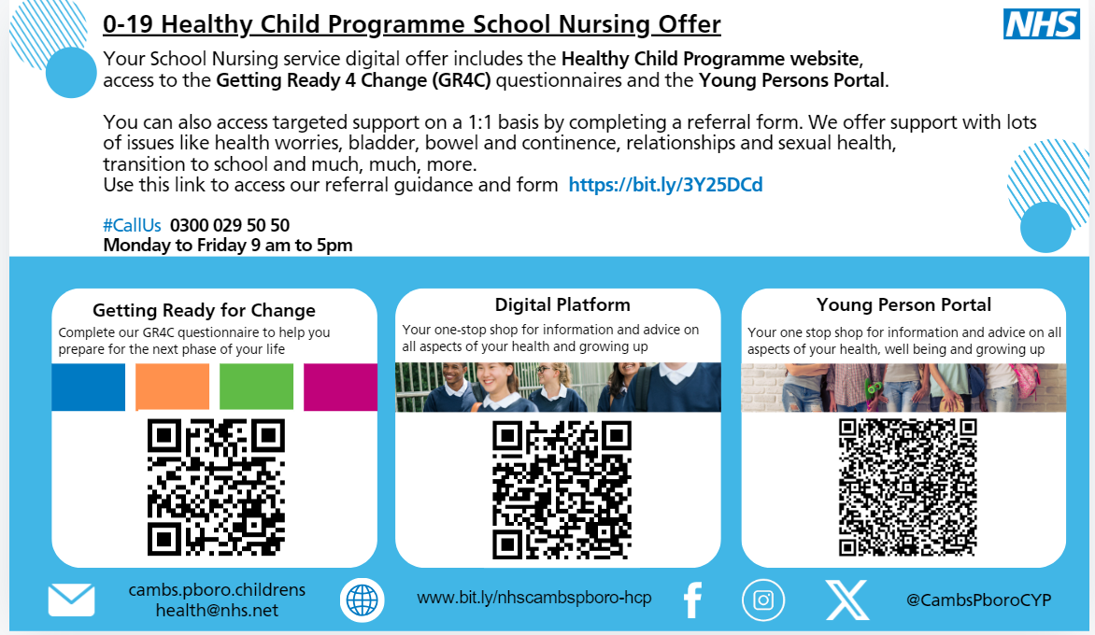

**Delivering excellence in Children and Young People’s Services**:

a partnership between Cambridgeshire Community Services NHS Trust and

Cambridgeshire and Peterborough NHS Foundation Trust