Notes for schools for using Teach in Cambs website
Open the Teach in Cambs website here: https://www.teachincambs.org.uk
Click `Login’ (top, right of screen) and log in using the username and password that the CCC Schools Recruitment Team have provided you with:
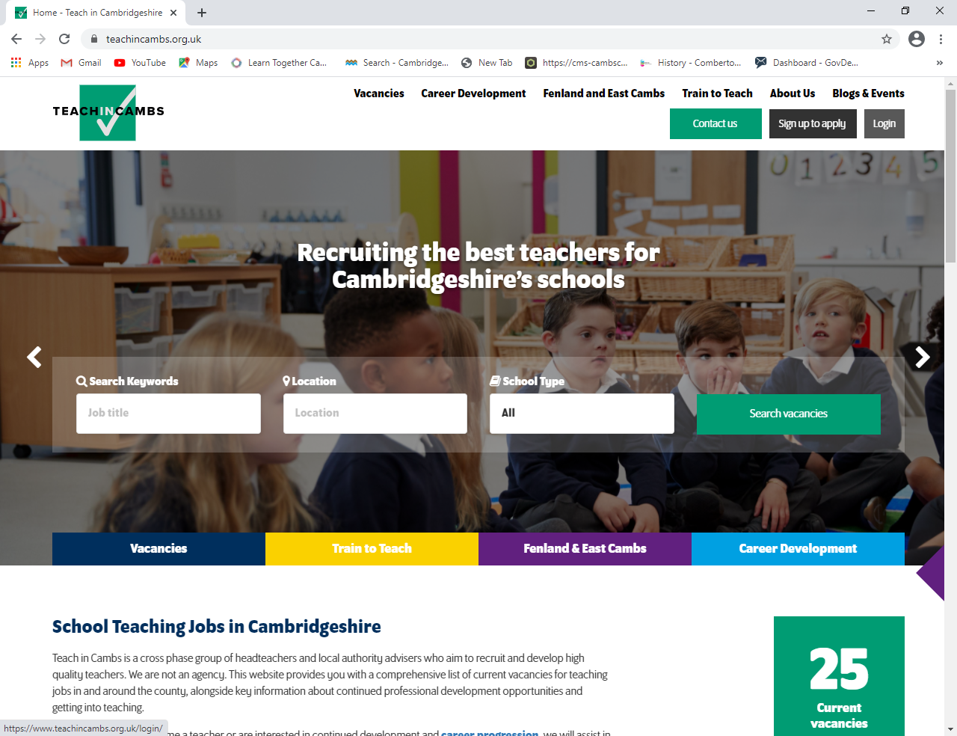

- Updating your School Profile
Once you have logged in, click the drop-down arrow next to the person symbol in the top, right corner and select `My Account’:
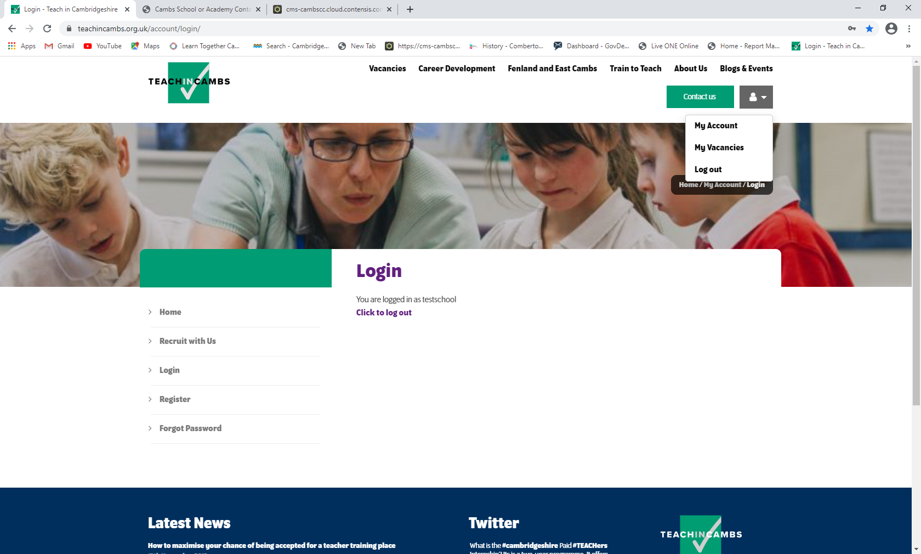

Select `Update School Info’ from the list of options on the left, then you will see the following:
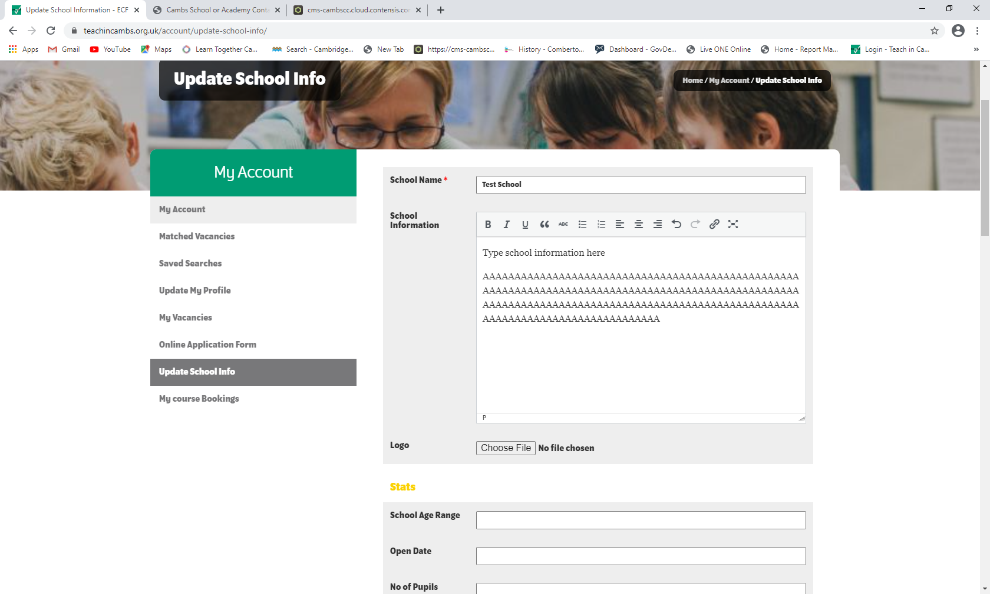

Write your school information in the text box provided, as well as the other details requested on that page:
For the logo: Select `Choose File’, browse to your saved logo, double click it and its title will appear on the page.
Click `Save Changes’:

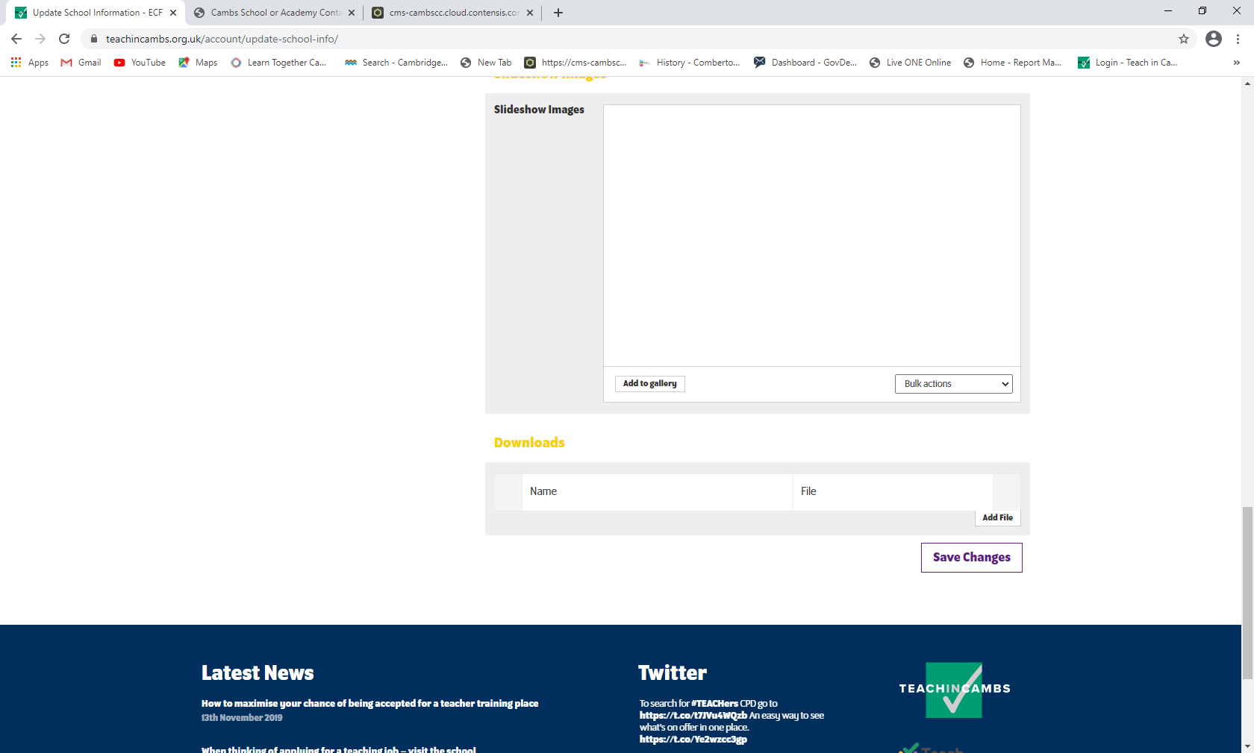

You also have the option on the `Update School Info’ page to add `Slideshow Images’ which will then display and to add files (although these are not necessary).
Save Changes

When somebody clicks on your school on the live TeachinCambs site, they will now see your school displayed, including the logo and the information you’ve provided. See below:
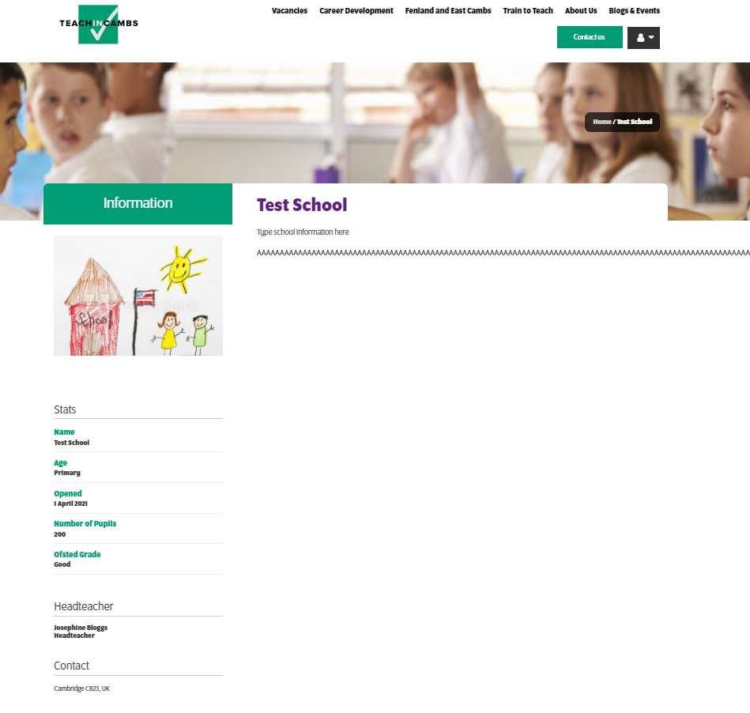
- Adding a school vacancy to the Teach in Cambs website:
Click the drop-down arrow next to the person symbol in the top, right corner and select `My Vacancies’:

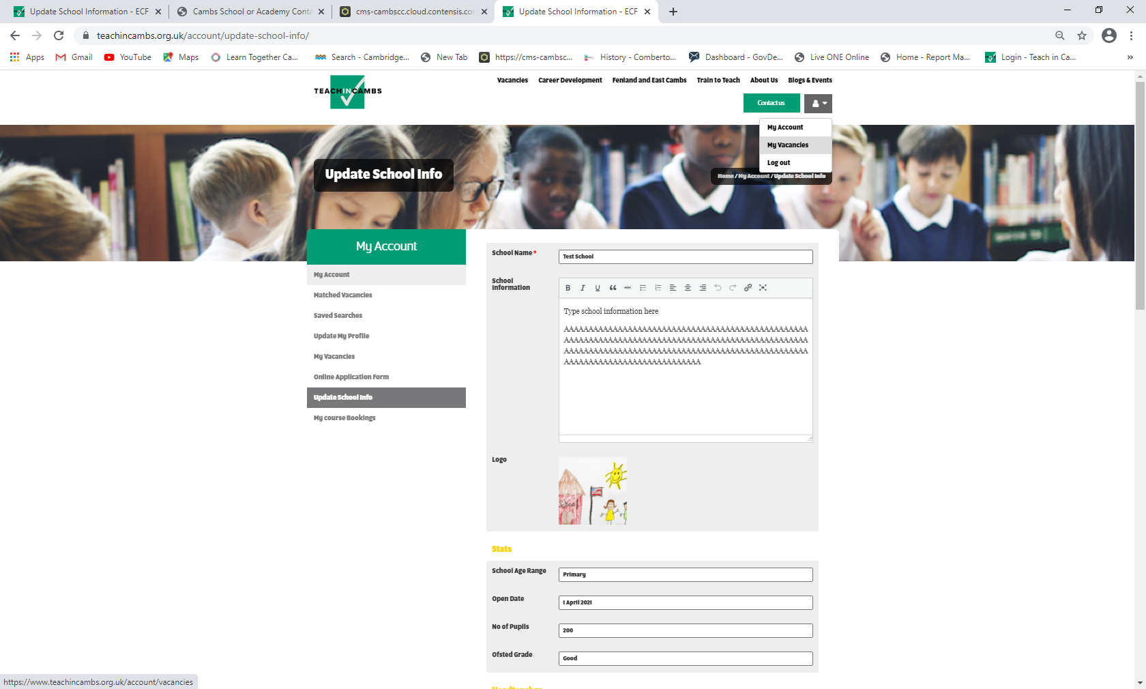
Under `Manage Vacancies’, click `Add New’:

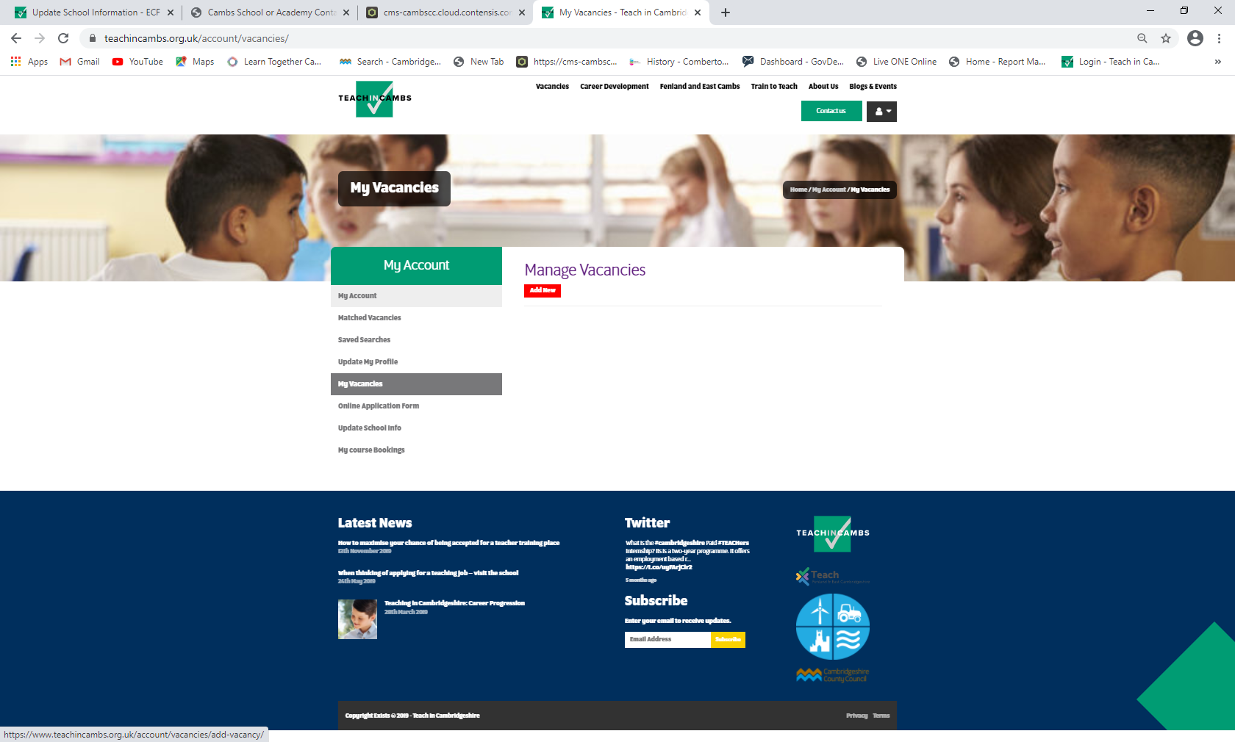

Fill in the details requested on this page (* indicates mandatory fields):
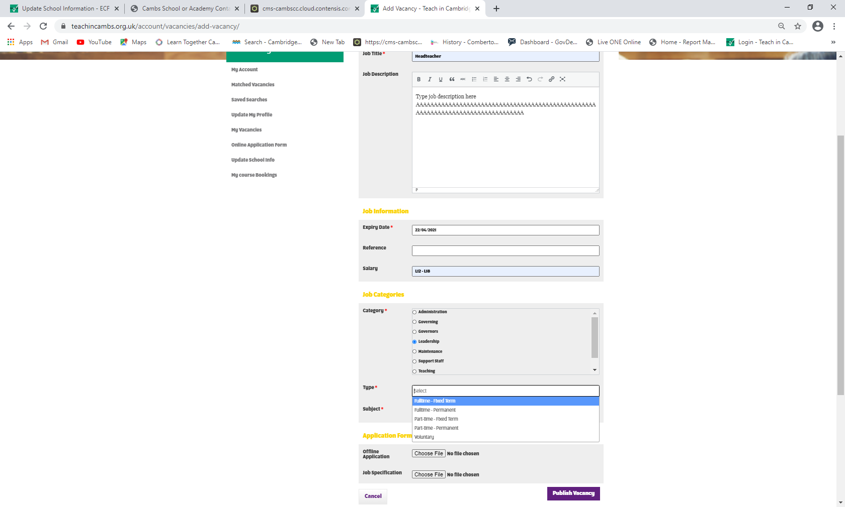

Job Title

Job Description (Copy and paste text into the text box)

Expiry Date

Reference (your own job reference)

Salary (for example, L12 – L18)

Category (for example, Support Staff, Leadership, Teaching etc)

Type (for example, Fulltime – Permanent, Part-time – Fixed Term etc)

Offline Application (Upload the application form you wish to use here, if you don’t want candidates to apply directly through this website)

Job Specification (Upload the Job Specification document here)

Select `Publish Vacancy’ when you have finished filling in all of the job information.

Once you have published the vacancy you will be able to see it listed under `Manage Vacancies’:

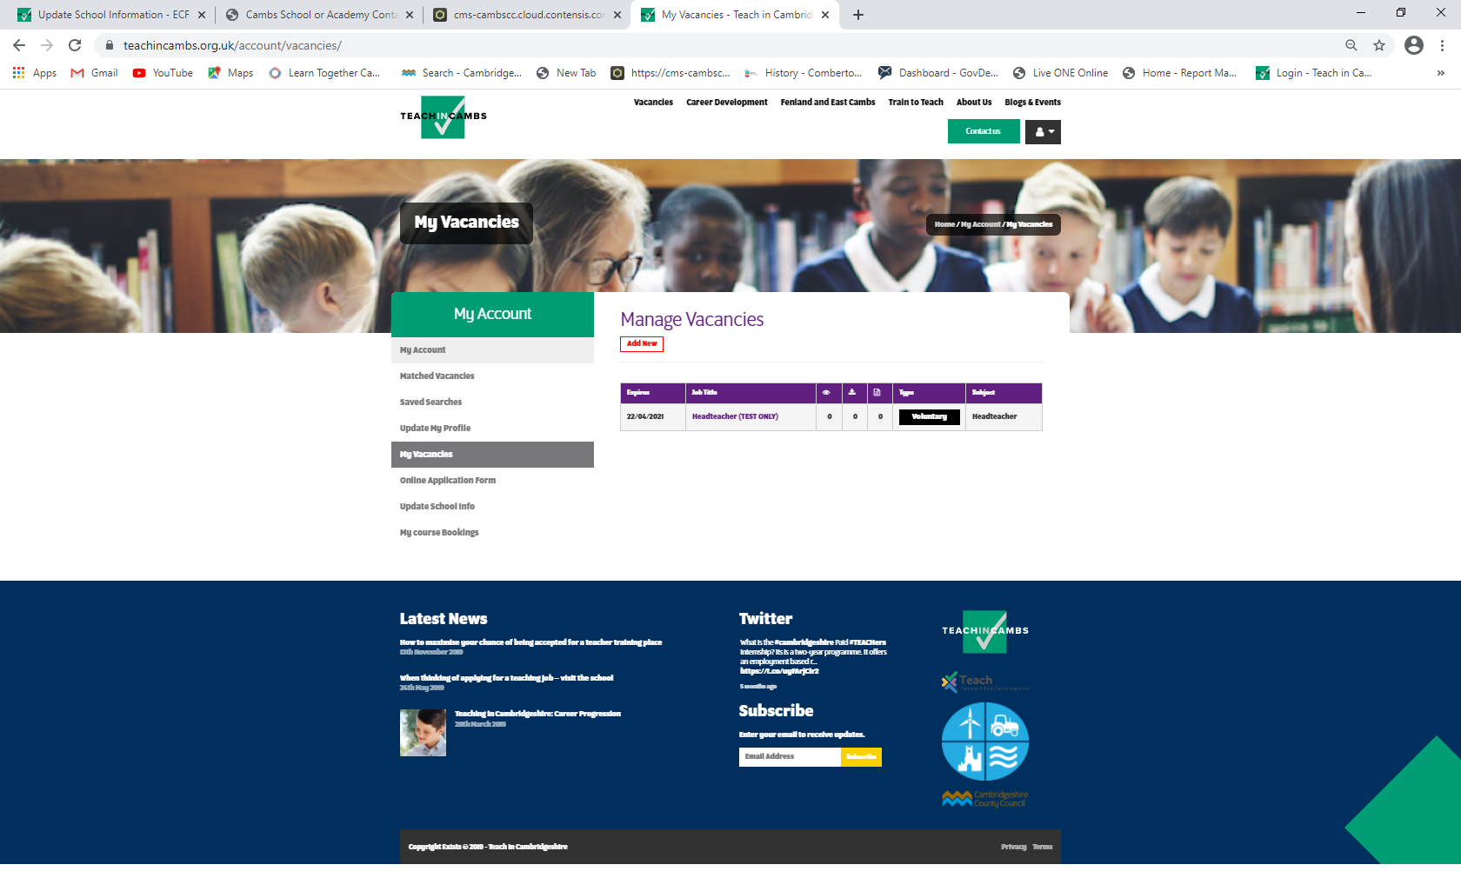

When somebody goes to the Teach in Cambs website and searches for `leadership’ vacancies they will then see the following vacancy details:
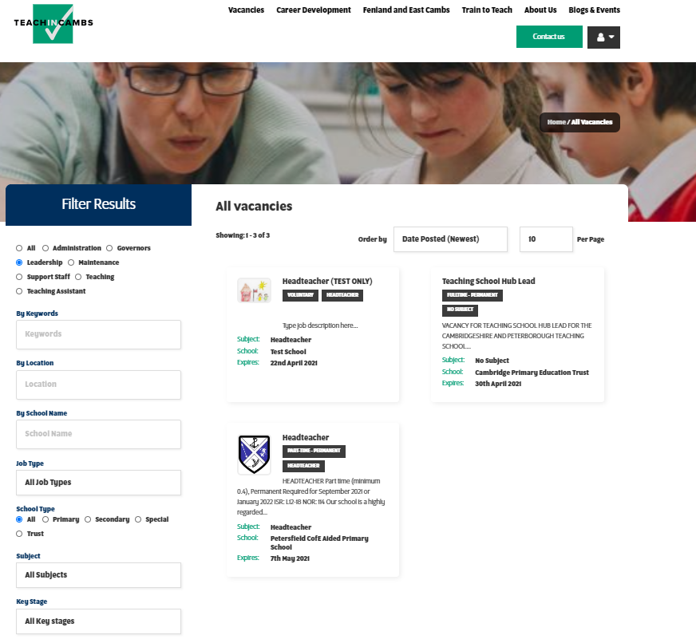
If they then click on the heading `Headteacher (TEST ONLY)’, the following details will be extracted:
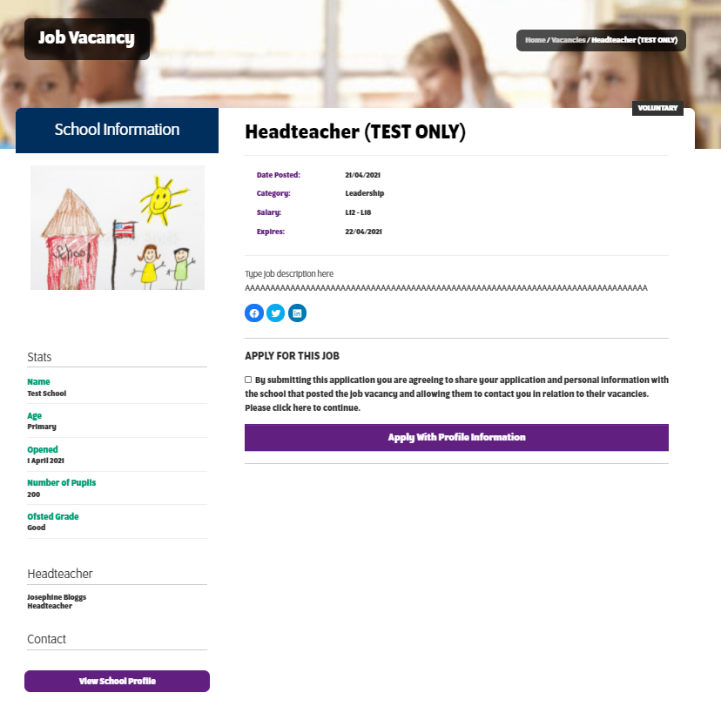
Prospective candidates are then able to apply directly by clicking `Apply With Profile Information’.
- Amending a school vacancy
Log in and select `My Vacancies’ as above. Click on the `Job Title’ of the vacancy you want to amend and from there you will open the advert and can amend the Job Description:

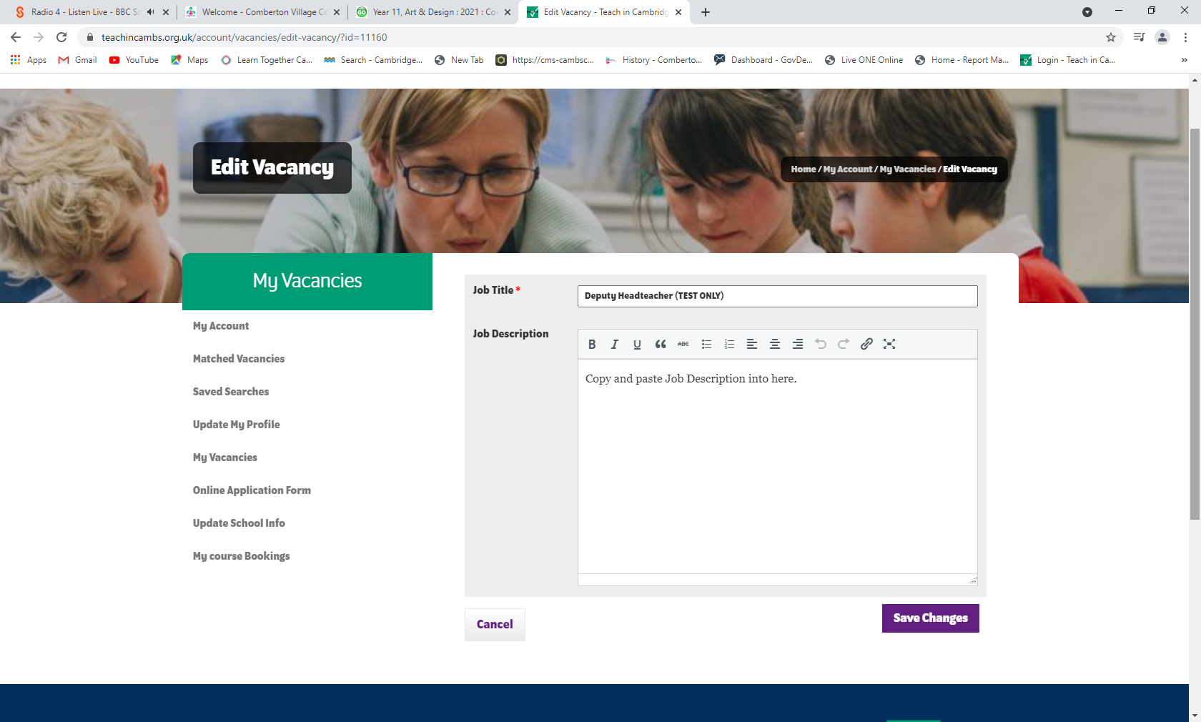
- Monitoring your school’s vacancies
Log in to your account (as described above) and select `My Vacancies’. You will then see the following:
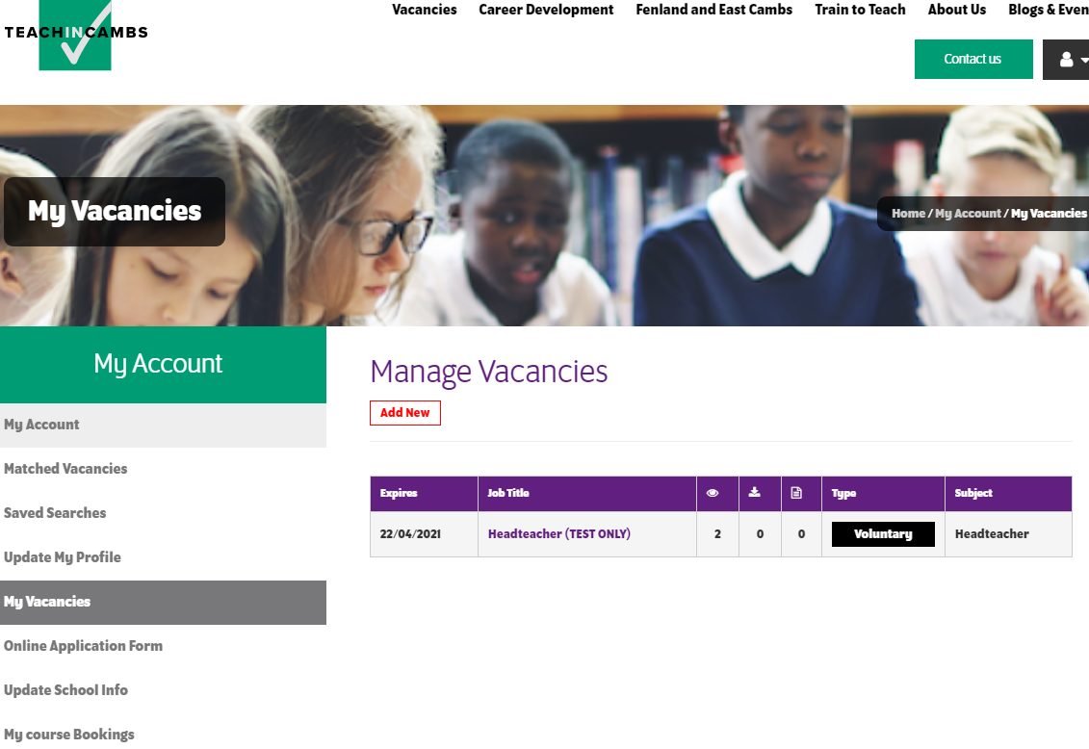
The eye symbol will show you how many views your vacancy has had.
Applications can be submitted by completing the form built into the website and the page symbol shows you the number of applications that have been submitted through the online form:

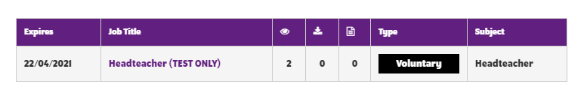
Click the number of applications to view and download them.

