Data Services, including Fisher Family Trust – 2022/23

FFT Aspire, School Self Evaluation Booklets, Governor Dashboard, attainment analysis, statutory census and assessment data collection support

Description of Service

The Education and Targeted Systems Service will work with the Learning Directorate to support schools by offering a range of services as detailed below. This package offers access to Fischer Family Trust Aspire, analysis of attainment data, support for statutory data collection processes and maintenance of key data items.

Services offered

Fischer Family Trust (FFT) provides data and analyses to schools under a subscription licence.
FFT Aspire is the reporting and data tool for schools, LAs and Academy Trusts. It provides key target setting and school performance evaluation information using the latest curriculum and accountability measures – quick and easy access and providing in depth analysis to support future planning and preparation for Ofsted inspections.

FFT delivers the latest pupil performance information with valid comparisons across a wide range of indicators, accurate and insightful information enabling pupils to achieve their full potential and schools to improve. It provides a set of interactive dashboards, data is presented in an easy to use format allowing schools to quickly evaluate past performance, identify strengths and weaknesses and set challenging targets for the future. Summary and subject Dashboards are currently available from KS1 to KS5 .They are designed for a wide range of users including teachers, subject leaders, department heads, and senior school leaders.
The LA has purchased licence subscriptions for all schools to ensure that best value is achieved for all. It will cost substantially less to purchase a licence for FFT from the LA than from FFT direct.
https://fftaspire.org/Account/Login?ReturnUrl=%2fHome%2fOrg10144#

- Target setting - Aspire provides a personalised approach to pupil target setting, underpinned by national progress data. FFT’s range of benchmarks – average, high or very high progress – can be used to set the right level of challenge for your pupils.
- Targeting and monitoring of key groups.
- Access to Student Explorer and Collaborate features.
- Supporting self-evaluation – The starting point for effective pupil and school improvement is understanding your school – identify key strengths and weaknesses, analyse subject and pupil group variation.
By comparing attainment and progress in your school to the attainment and progress of pupils nationally, FFT Aspire provides high quality self-evaluation reports early in the autumn term when it’s most likely to have the greatest impact.
For Secondary Schools differentiate between first and best entry performance as well as well as Wolf/non-Wolf comparisons. Use the interactive self-evaluation dashboards to analyse Attainment 8 performance in your school.
- Access to the FFT Governor Dashboard
- First line system support provided by IT and Digital Service
Data Services - Access to reports or systems, to support performance data analysis, evaluation and review. For Primary schools access to a range of Nova reports via the Perspective Lite portal, and for Secondary schools access to Nova Reports that have replaced EPAS online.
- Helpline support for completion of Statutory School Workforce and School Census returns (all schools). This does not include support for MI systems used in schools e.g. SIMS, Bromcom, Pupil Asset, and ScholarPack.
- Helpline support for completion of statutory assessment data collections (schools required to complete EYFS, Phonics and KS1 collections only). This does not include support for MI systems used in schools e.g. SIMS and other systems.
- Data to support transition from Primary to Secondary (secondary schools only), Infant to Junior (junior only), Reception admission (primary/infant only).
- Support for locating missing assessment data (all schools)
- Support for schools in relation to data quality in terms of the regular data received from schools own MI systems, e.g. ensuring correct UPNs, querying changes of name, check and confirming current addresses for children, etc. (all schools)
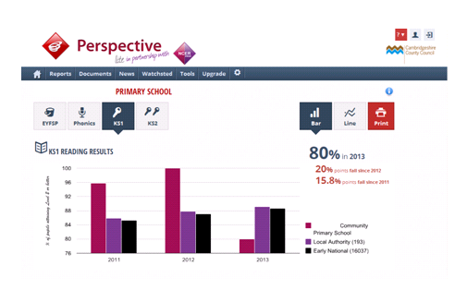
- For Infant, Primary and Junior schools online access to analytical reports
- For secondary schools access to new system that has replaced EPAS online
The Cambridgeshire package represents a significant reduction in FFT direct prices, based on a bulk purchase discount which has been secured. By purchasing the package from the LA schools will benefit from many additional data services for an equivalent price.

Costs of service

Details of packages offered: | Costs
Secondary Academy (per school) | £1050
Primary Academy (per school) | £350

Contact for more information:
Maria Clough
Tel: 01480 379862
Email: educationandtargetedsystems@peterborough.gov.uk

