Locking a Budget on SBS

Ensure that the budget profile you are locking is fully up to date and reporting accurately.

Go to Console > Budgets > Management
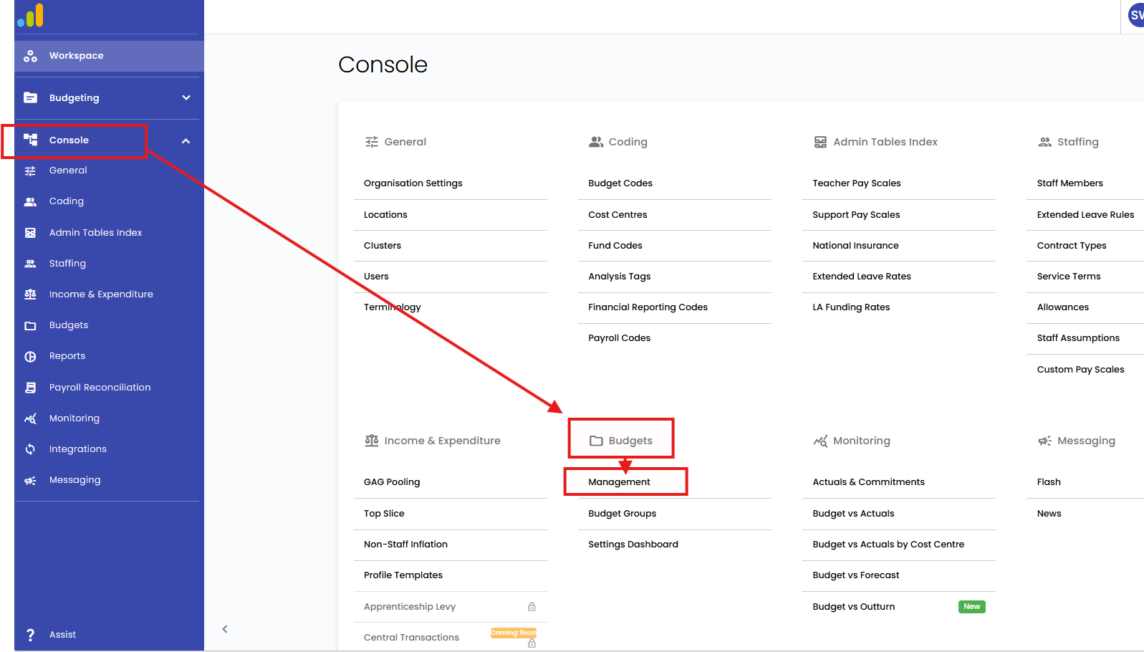

Type the school name in the search box
Select the budget needing to be locked from the list by putting a tick in the box on the left-hand side of the budget name
Click on the three dots in the top left corner
Select lock.

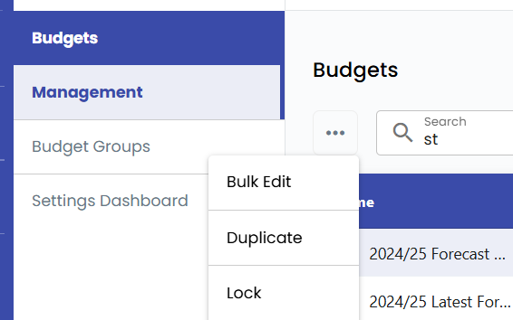

The list will then update, and a new entry should be visible.
This will be named “{name of the original budget being duplicated} (Duplicate – {date of duplication} {time of duplication})”.



The original budget should show a padlock symbol at the end of ‘Name’ cell.
E.g

Renaming the Auto Duplicate

Rename the auto duplicated budget by clicking on the budget needing to be renamed from the list > click into the budget profile > core settings > edit budget.

Change the name of the budget in the ‘name*’ box (maximum of 32 characters > save budget.

You should be forecasting monthly. This should be done once you have fully completed your SMER, all variances on the SMER Summary tab have been investigated into, corrected if needed, all reports and figures have been updated in the SMER and you have imported your final CEA into SBS.
Your forecast should be done in a budget called Month Name (the last complete period) Year SMER -School Name.
and then when finished, you should lock the budget you forecasted in and rename the auto duplicate it creates when you lock it.

