CEA Info & Import Procedures

CEA creating & uploading
- Your CEA report will be used to update your actuals on SBS.
- Please ensure you have posted all your journals (including your Payroll Journals) before running any month end reports.
- The minimum columns needed on your CEA report are shown below
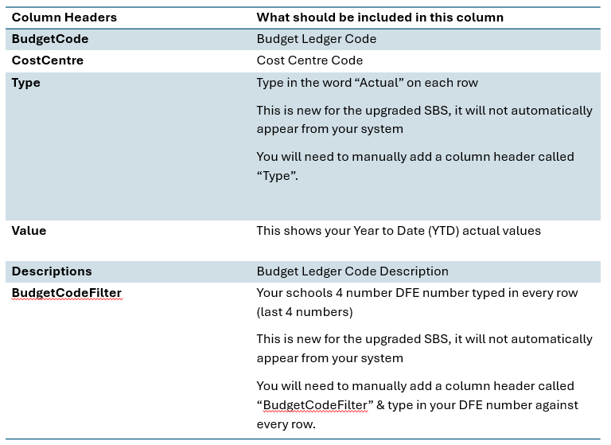

CEA uploading
My suggestion would be to run your CEA report and amend your Header Columns to show per the previous slide. With no spaces in column headers. Before you import into SBS.
This is an example of the column header changes on an FMS report:
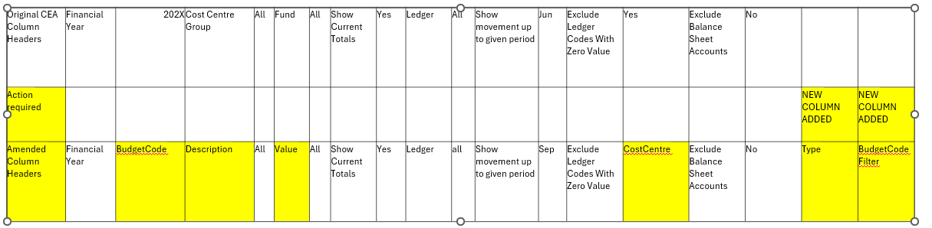
This is an example of the column header changes on an BROMCOM report:
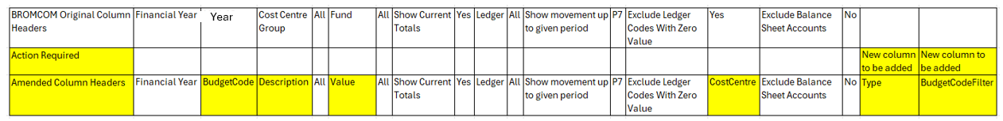
For Arbor schools
Please check you have 2 columns called Type & Budget Code Filter and there are entries for these in each row you have data for. If there isn’t could you please add to your report?
You will also need to change the Column Header called Description. Please and an s to the end, as it should be called Descriptions.
Please check you have column headers as listed on this page
Once you have made the amendments, please save your CEA as a CSV file, by selecting the file type as: This is so that it can be imported into SBS.

Importing your commitments
(Does not apply to Arbor Schools)

There is an option to import your commitments at the same time as your actuals etc
A few schools have now asked if they can import their CEA Commitment figures into SBS so they show in their Budget vs Actuals report.

This can be done but it is a bit long winded to get it there, as it requires you to manually change the CEA report before uploading.

To do so, these are the steps you will need to follow:
- Please copy the rows in your CEA with commitments in them,
- Paste these at the bottom of the CEA file and remove all other column figures just leaving the commitments figure on these newly pasted rows.
- Move these commitment figures into your value column.
- On these commitment rows, in the Type column, change the commitment rows Type from Actual to Commitments
- Please do this for all rows with commitments values in them.

This should then upload & you should see your commitments in the commitments column on your Budget vs Actuals report.

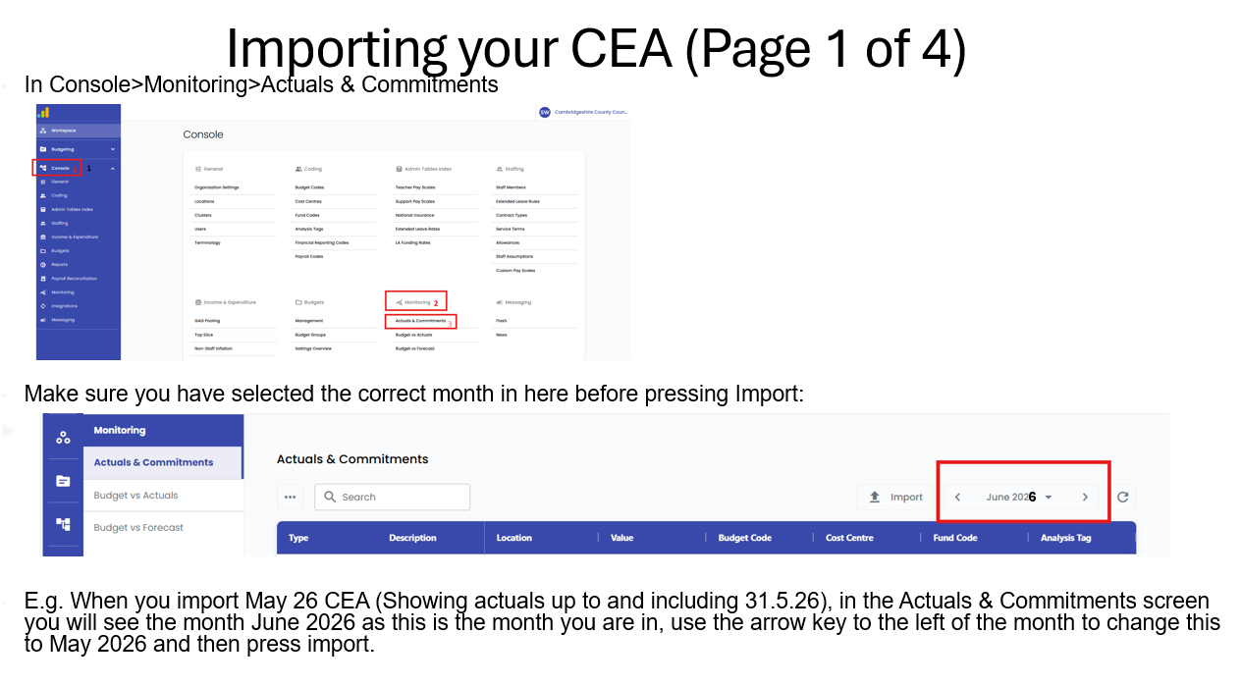

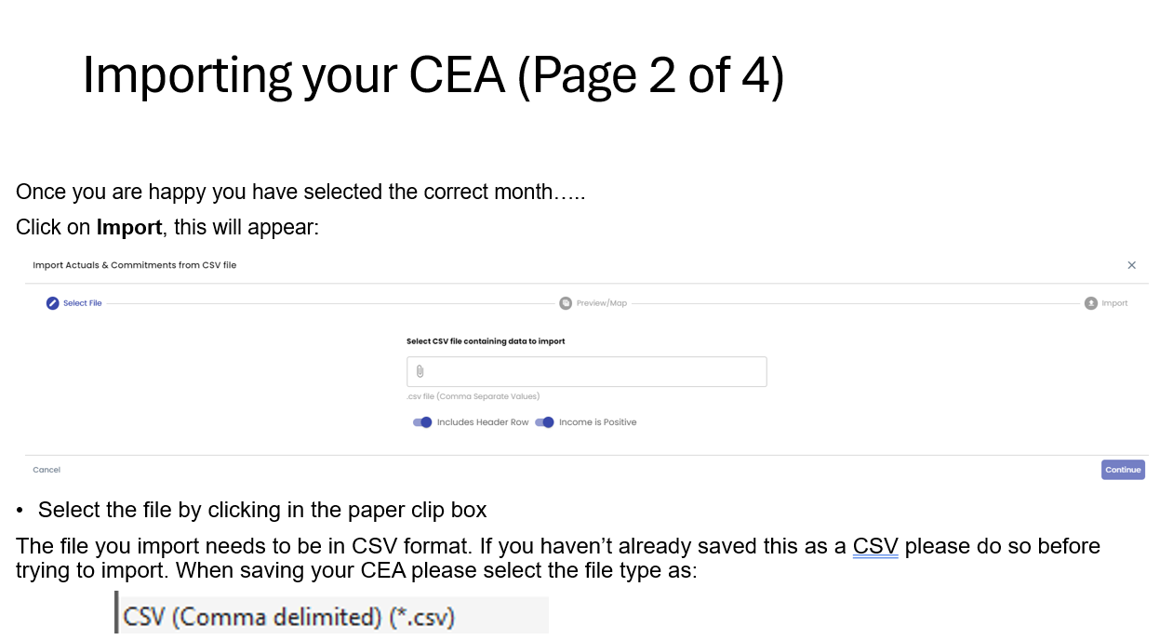

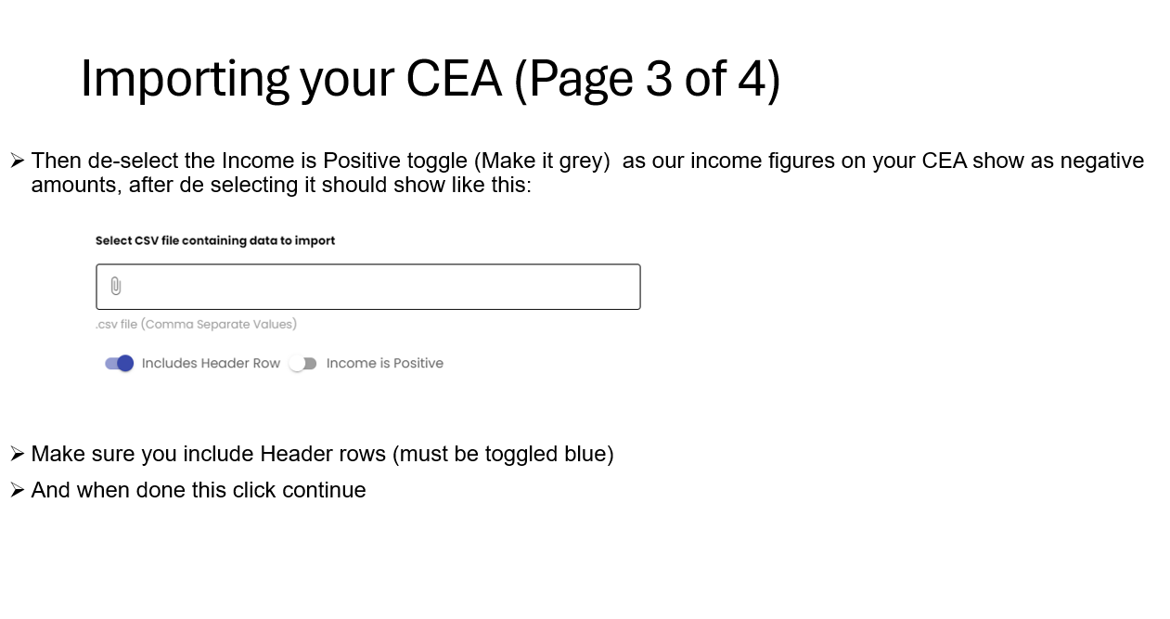

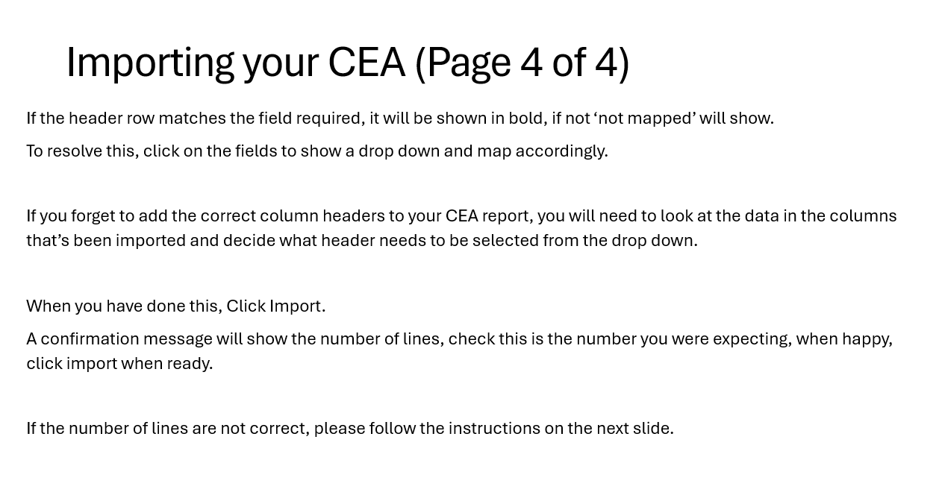

Some schools are finding when importing their CEAs it is trying to import the wrong number of rows (when they have deleted a row(s))
To stop this happening, make the amendments to your CEA. Copy just the cells with figures/data/words in them, and paste into a new document, then save as CSV for importing into SBS
When you have done this, Click Import.
A confirmation message will show the number of lines, check this is the number you were expecting, when happy, click import when ready.
Message will then show any errors or if import is successful, click done to close.
If an error message appears please follow the next instructions

- Please do not delete any lines on your CEA if you get error message.
- If errors exists, please email SBS queries attaching the CEA and also including a screen shot of all error messages and I will look into it for you.
- If SSCT is taking too long to set up a new Cost Centre, for this month, please amend your CEA manually to a code that will be accepted by SBS (previously set up) and then when the new cost centre is set up please ensure the actual transaction has gone to the correct code, and next month it will show correctly.
- Once corrections have been made, please follow the previous screens to Import.
- Remember – please de select Income as Positive (Make the toggle Grey)

Removing your CEA

If you notice your imported CEA is incorrect in SBS.
Go to Console > Monitoring > Actuals & Commitments> select the month they are incorrect for> now click on the 3 dots and “clear month”> Then re import with new CEA.

