Budget Entries vs Budget Adjustments
There are two ways to make amendments to your forecast (working) budget. These are Budget Entries & Budget Adjustments.
The below shows the differences and how to do both.

Amending Budget Entries
We would recommend using this method for income and non-staffing expenditure when there is a permanent change or reforecast in-year.
E.g. you included £5,000 in the budget for insurance, but the actual invoice was £4,000. There is only one transaction in the year, so the actual expenditure figure will not change.
You would need to highlight any such changes in your next report to Governors, to allow them the chance to discuss and review this.
The benefit of doing so is by changing the figure in the forecast (working) budget will help inform future forecasting and budgeting.
When budgets are created in SBS for next financial year (usually done towards the end of January), a copy is taken of your most recent monthly SMER profile. Ideally this should be your December forecast/working budget. If you have regularly amended budget entries in this forecast budget, the starting point for next year will be as accurate as possible.

To amend Budget Entries in SBS:
• Select the forecast budget you wish to amend in the top right corner
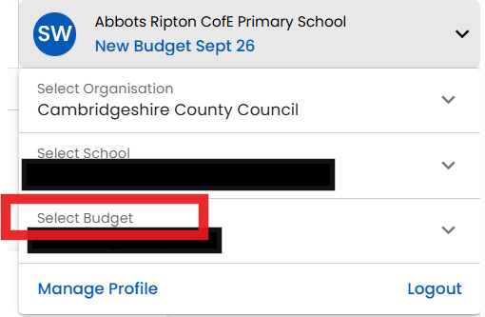
• In the left-hand side bar: • Budgeting > Non-Staffing >
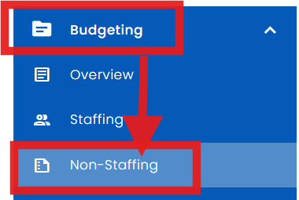

> Hover to the right, to show Budget Entries:
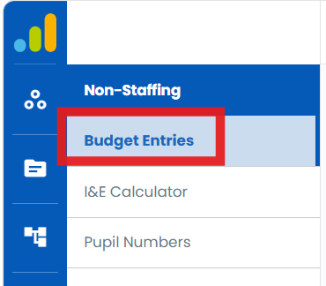

> Use description or ledger code in the ‘Search’ box to locate the correct entry
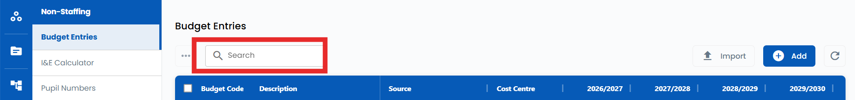

> click into the entry > change the amounts in the lower section e.g as shown below (please ignore the amounts)
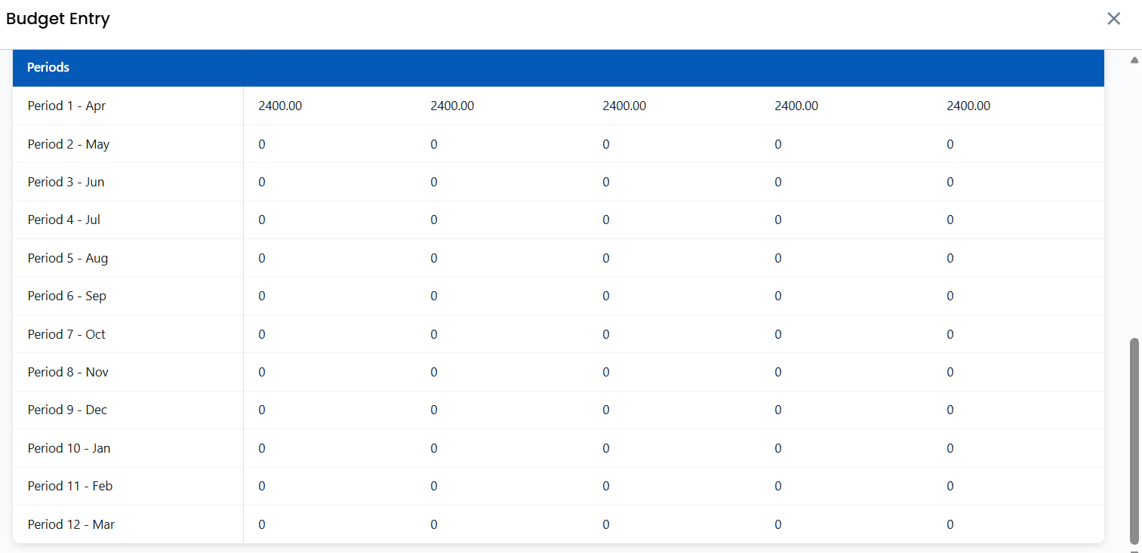
> Save & Close
•> Check the forecast shows as you want it to (Budget Analysis Report or the BvA report)

Using Budget Adjustments
Budget Adjustments are best used for short term or temporary changes to the budget.
E.g. if you’ve had a £15,000 donation from your PTA, but the donation hasn’t been spent yet and expenditure isn’t included in the budget. Adding a budget adjustment to the related expenditure ledger code will show the planned expenditure in the forecast.
Then by the next forecasting/reporting period, the expenditure will be showing so no further budget adjustment will be required. Adding the initial budget adjustment will have prevented income being overstated.

Budget adjustments need to be added/reviewed each time – so aren’t ideal for permanent/long term changes.
To add a Budget Adjustment in SBS:
• Fully expand the Budget Vs Actuals (BvA) report by clicking on:
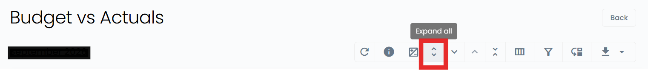
> Click on the three dots to the right of the ledger code description
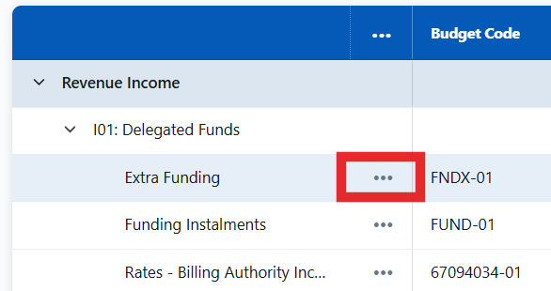
> Click on ‘Add adjustment’
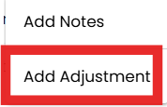
> Add the required figure > Save.
Check Columns K (Adjustments) & L (Projected Year End) on the BvA to ensure that this is showing how you planned.

PLEASE DO NOT just add an adjustment to revert the Projected Year End figure to the Governor Approved Budget (GAB) figure to make the variances disappear.
It is a requirement of the forecasting process that the figures are reviewed and checked. Automatically forecasting back to budget may mean that you miss something important.

