How to set up a payroll rec budget on SBS

This advice will depend on where you are at with approval of your 26/27 Budget.

Assuming your 26/27 Budget is your latest version with your latest staff information, if it’s not, please chose your budget with the most accurate staff information in it.

You will need to copy (Duplicate) this budget version in SBS and rename it April26 Payroll Rec – Your school name.

To do this you will need to go into Console>Budgets>Management> search your school name> Click on the little tick box to the left of your latest budget version, the one with the latest staff information in it>3 dots>Duplicate:
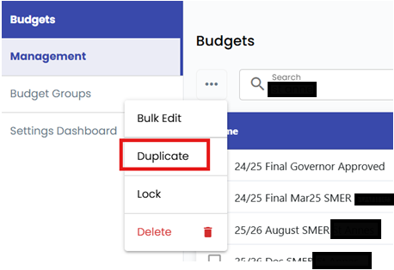

Rename the duplicate it creates as April 26 Payroll Rec-Your school name.

As your staff in April 26 haven’t been paid what is in your 26/27 budget as this assumes an inflationary/payrise element for both teachers w.e.f 1.9.26 and Other support & TA staff w.e.f 1.4.26 by having the 2026/27 Assumption Table selected in the staff assumptions table cell, you will need to change the staff assumption table within the April 26 Payroll Rec budget.
You do this by selecting the April 26 Payroll Rec budget you have just created via Console>Budgets>Management>search your school name> Click on the April 26 Payroll Rec – school name budget and Edit Budget> then go to Assumptions> and select the Payroll rec staff assumptions table in the Staff Assumptions table drop down (at the bottom of the assumptions screen)

Press Save Budget.

In the top right of SBS where your initials are shown, select the budget you have just created.

Import your Payroll file into SBS as you did last year.
Then check the variances.
You will need to investigate into all variances and make notes on why they have occurred.

Your figures should look correct if your contracts on SBS are correct and you have done the above changes. If they don’t, please check the Basic Pay figure on SBS to your EPM report, if correct then it’s not due to the changes you have made above.
I would check support staff first as the changes above should correct these.
Teachers didn’t have increases build in until September 26 so will probably not change.
If you have variances you cannot explain after doing all of the above, please contact Sam by email (sbsqueries@cambridgeshire.gov.uk). I may have forgotten to give you a step in the above 😊

Can I please remind you of this guidance:
On the Learn together page:
Cambridgeshire Schools Latest News and Updates

If you need to make any changes to the contracts within SBS as EPM/Your payroll provider is correct and SBS is incorrect, please do this in the April 26 Payroll rec budget, check it corrects your payroll rec and then if it does please make the changes needed to all live working budgets, so that you report the most accurate position.

You will need to repeat this process each month, but copy your latest forecast SMER budget instead of your 2627 Initial/Gov Approved one, until all staff have been paid their back pay for their pay rises/increases etc. At the point of paying all staff their updated/increased salaries, you can then do it in the same latest version of your SMER budget.

