Adding / Amending your Opening Balances on SBS
Always ensure you are in the SBS budget profile you wish to amend – as per the details in the top right-hand corner.

To change this, you should click on the drop down to the right of the field.

Now go to Budgeting>Overview>Opening Balances. It will show figures in the value field per the budget that was copied (duplicated) to set up your budget, this will be incorrect at the start of the financial year until you amend it:
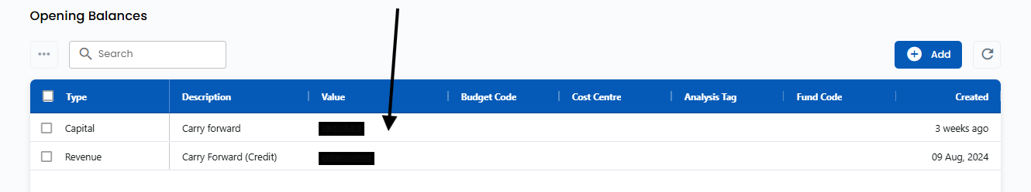
This screen should reflect your current/ latest carry forwards for each fund.
W.E.F 1.4.26 you should show a row for each fund.
Your schools 26/27 budget opening balances screen should reflect your SSCT approved final 25/26 fund balances, fed back to your school at year end following your final 25/26 YE SMER review.

To amend the opening balances the budget currently shows, please click on the value amount:
and amend the figure, and also add details in these fields:
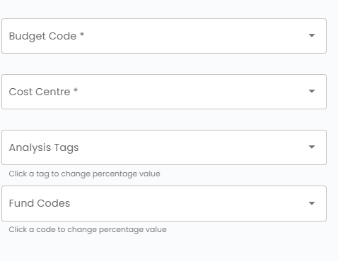
Then press save and close.
Please do this for all funds.
All funds should be shown in the opening balances screen.

To add a new row please click on the add button:
Then complete the below fields:
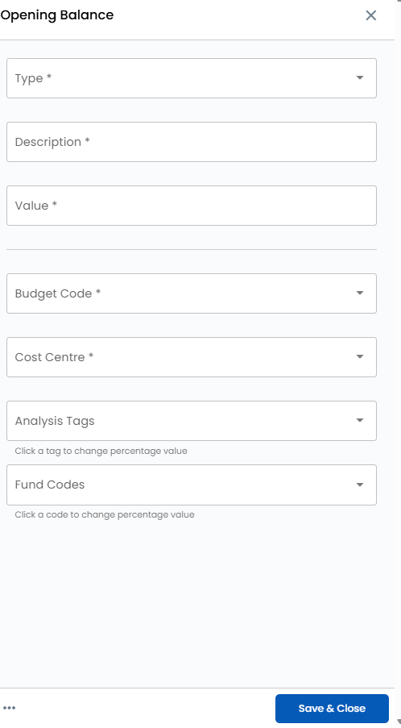
And when complete press Save and Close.

