Actions required by School to successfully apply the new Teacher & Support Pay Scales

The DfE have accepted the recommendation of the STRB in relation to Teachers Pay award for 2026/27 & 2027/28.
Support staff unions accepted the 3.3% offer on 21ST August 2026: https://www.gmb.org.uk/public-services/local-government/njc-green-book-noticeboard

To ensure you are forecasting correctly (that the new Teacher scales, Support scales & Assumption tables feed through correctly) you will need to follow these short steps to every live working budget you intend to rely on.
These steps are crucial to ensure that the new scales etc feed through and should not be ignored.
These changes should not be applied to any Payroll Reconciliation budgets that you use or any Governor Approved budgets.
When you start to pay your employees the new pay rates, please check for guidance on how to complete a payroll rec on Learn Together: SBS guides and procedures
To make the amendments that are now needed, please follow the steps below:
- Log into SBS and navigate to the “Console”
- Click “Management” under the Budgets header

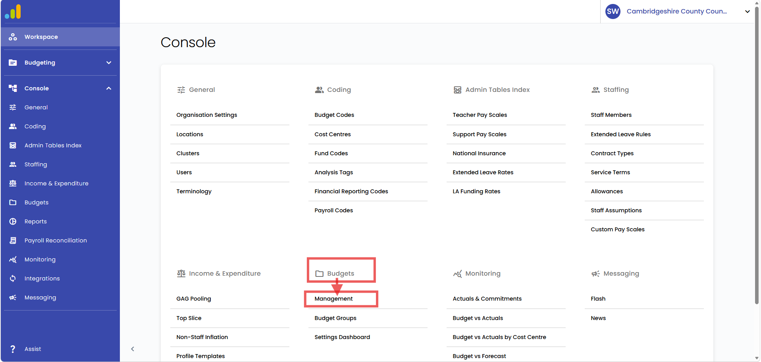
- In the search field enter your school’s name. This will show all your budgets
- Find the budget that you wish to apply the new pay scales & assumptions to from the list.
- Click the budget name
- Navigate to the “Assumptions” tab:
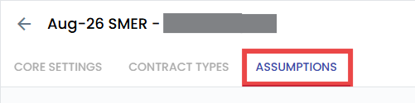

- Click Edit Budget
- Please add a new Pay Scale Table under the Teacher Pay Scales Table section, by pressing the +:
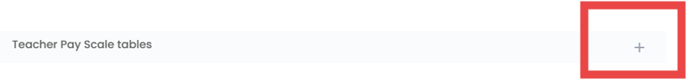
- Set the effective date to 01/09/2026:
- Then in the drop down select Teacher - 2026 (Prov. 3.5%):
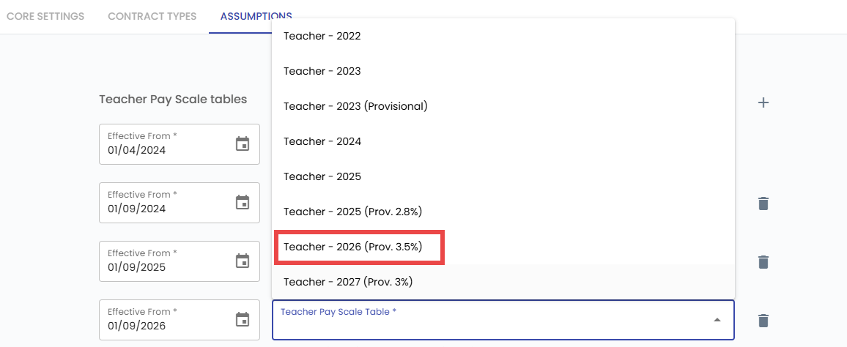

- Please amend the Support Pay Scales. To do this, add a new Pay Scale Table under the Support Pay Scales Table section, by pressing the +:
- Set the effective date to 01/04/2026
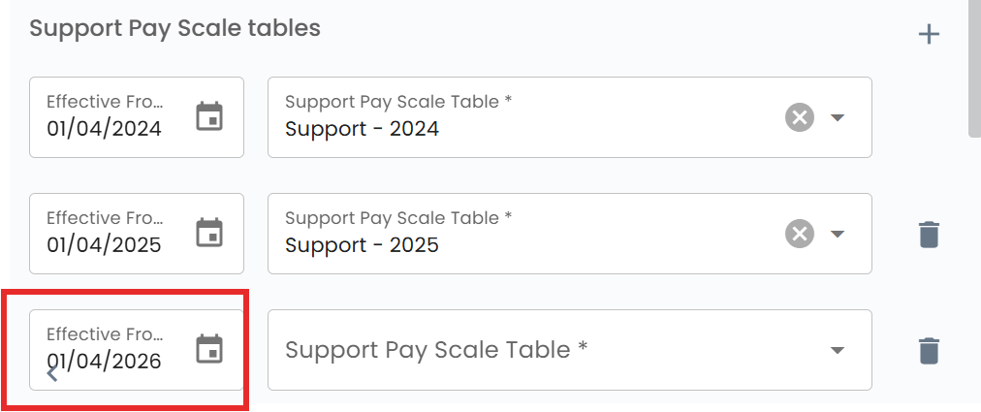
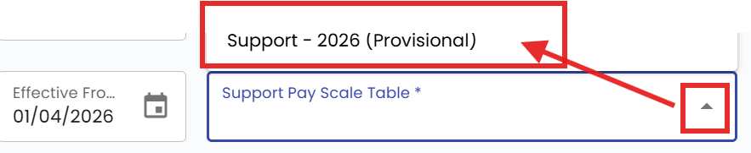
- Then in the drop down select Support – 2026 (provisional):

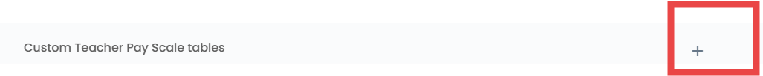
- Amend the Custom Teacher Pay Scales by clicking +

- Set the effective to 01/09/2026 and select SSCT Teacher Pay Scales Sept26 from the dropdown.
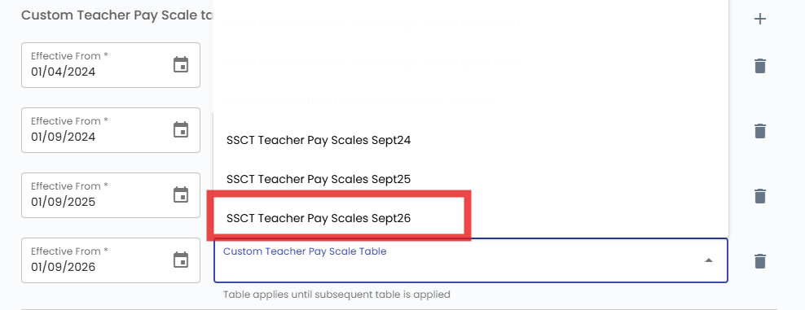

- At the bottom, for the Staff Assumptions Table, click on the drop down:


and select:
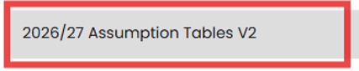
This takes out the inflation amounts for the financial year 26/27 as the new pay table rate amendments made above include them.

- Once you have checked and updated where necessary to mirror the set up above, click “Save Budget”
*Please note, you must click “Edit Budget” and “Save Budget” even if your assumption tables match as outlined above and no changes are required.

You should now repeat these steps for any additional budgets that you intend to rely on for 2026/27 and beyond. These may include specific scenarios or alternative budgets that you are working on.

We have updated all SEN & TLR allowances, but if you use any others, please let us know if you need these inflating via the sbsqueries@cambridgeshire.gov.uk email address.

Schools Budget Support Grant
The DfE have announced an additional grant to support schools with the increased cost of these pay awards in the form of the School Budget Support Grant 2026 (SBSG26). Further detail was published to learn together, and DfE guidance can be found here.

The Budget Calculator has been updated to include indicative allocations and other grants. This can be accessed here Cambridgeshire Important Documents.

Teachers Pension Scheme changes
The DfE have announced that from 01/04/2027 that Employers Contributions for the Teachers Pension Scheme will decrease by 11% from 28.6% to 17.6%. As part of this reduction from April 2027, the DfE will be reducing National Funding Formula Factor Values from April 2027 to reflect the reduced costs in schools as a result of this change.
At this time, the LA will not be reducing the Employers Contribution rate in SBS from April 2027, nor will there be any changes to future funding predictions to take account of any reduced NFF values. The DfE intend for this process to be cost neutral to the Sector as a whole, but there may be gains and losses at a local level. As a Local Authority, this is still high level information and we cannot provide further information at this stage. The DfE have provided a technical note available here. We will provide more information as we progress through the budget setting process for 2027/28.

Any questions please email the sbsqueries@cambridgeshire.gov.uk

