As you are aware SCP2 will be removed from 1.4.26, all contracts currently being paid on SCP2 will need to be amended to SCP3 on SBS.

To do this you will need to go into each of your live budgets
You will need to amend all your live budgets separately/individually.
(Please do not amend your Governor Approved budgets)

To do this, go to the top right of SBS, this tile:
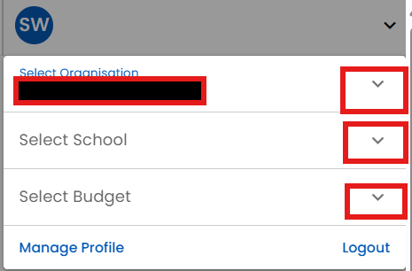

and select the correct details, for example:
- Cambridgeshire County Council will be in the Select Organisation field– please leave this as is
- Please check the correct school name is showing, amend via the drop down if needed
- And select the budget you would like to amend.

To quickly check which contracts need to be amended to SCP3, I would recommend you run a Staff Costings report. This is found in Budgeting> Reports.
Select the budget you would like to check, the budget year 2025/26 (as will show their latest SCP’s), then press Run Report.
There are columns showing periods Apr to August, September to December & January to March. They each have pay scales listed. Scroll down to check if there are any 2’s showing, and if there are please note them. Or you can export the file and highlight on Excel. These are the ones that need to be amended.

To amend the contracts, go to Budgeting> Staffing> Staff Contracts> Click on the contract you would like to amend> Go to the salaries tab.
If you haven’t got SCP3 listed, you will need to add a new row for this. To do this click on Add New

When you click on Add New, the Effective date is pre-populated, check it is showing as 01 Apr 2026. If it isn’t please change it.
Check Paid hours, Paid Weeks, Spot/Adjustment entries are correct
Then in the Scale Point field, click on the downward arrow and select 3
Check the Allowances field is correct.
Check ER’s Pension is correctly toggled. If pay pension it should be blue, if doesn’t pay into the pension scheme then it should be untoggled (grey)
Once happy click update.
Check the Salary tab is then showing correctly.

If in the following 4 years the contract will go up grades, please add these details into this screen by adding to the Add new screen. This will affect the forecasts and budget calculations for these years and will show the effect of the increases in SCP’s.
You can also select Auto-Increment to do so.
Please check each period (effective from date) is showing as it should and then click Save and Close.

Please do this for each of your live budget scenarios. Please do not amend your Governor Approved budgets.

If you haven’t already done so, please amend each of your live budgets pay scale tables per the instructions on the Learn Together webpage (here- Update 05.08.25). This shows all of the correct tables even though it primarily mentions NJC.

