Please check your Payroll Costing file to all reports listed in documents in the Learn Togethers Corporate Requirements page manually as well as importing file into SBS.
The file you import into SBS should ideally be your final file, but you can import the first draft, make amendments via EPM if you identify issues when doing your manual check, remove the report in SBS and reimport in the new updated report following amendments.
Have you paid your Teacher & Support Staff new rates in the Payroll file you would like to import into SBS?
You are now ready to import your payroll costing report into SBS. Click here for instructions on how to do this

There is no need to change the staff assumptions
In the top right (where your Initials show)

Click on the downward arrow
Select the Budget you have just created (the Payroll Rec Budget)
Please import your Payroll Costing file into your most up to date budget
(The one with the latest staff contracts entered)
Click here for instructions on how to do this

There is no need to change the staff assumptions
You need to create a separate Payroll Rec Budget to show expected pay rates at the current paid rates, to do this follow these steps
In Console>Budgets>Management>Search your school’s name> this will show all of your budgets> click on the box to the left of the name of your latest budget (the one with the most up to date contracts in it) > go to the 3 dots at the top> select Duplicate
The budget will be shown in the list with the name of the budget you duplicated and then in brackets (Duplicate Date & time you duplicated)
Rename this budget by clicking on it> Edit Budget> Click on the budget name> remove name and call it (type)> Month Year of the file you are importing Payroll Rec School Name> then go to the assumptions tab> remove all tables that have not been paid in the month you are checking (remove the future pay tables) to show the pay tables that have been paid> change the Staff Assumptions table to Payroll Rec Staff Assumptions> when done>press Save Budget.

There is no need to change the staff assumptions
Have you paid your support staff but not your teacher?
Or have you paid your teachers but not your Support staff?
If so, please follow the next steps

There is no need to change the staff assumptions
No
Yes?

Importing your Payroll costing file into SBS

For SBS’s Payroll Reconciliation to work, SBS requires three columns to be imported. These columns need to show Employee numbers, Payroll codes and the Total Cost (Actuals).
Other columns do not need to be deleted from the import file.
Please call the column headers
- EmployeeNumber
If you import an EPM costing report into SBS this will be column A’s column header
- PayrollCode
If you import an EPM costing report this will be column F’s column header
- Actual
If you import an EPM costing report this will be column R’s column header

The file needs all blank rows and subtotal rows deleting, it should also only have one column header row
SBS also needs a CSV (Comma Delimited) file importing, it will not accept an excel document.

If you are importing your EPM Costing report
Please download the excel report from the EPM portal
Please remove the rows that show your school’s name, address etc at the top of the report.
You also need to remove lines 1& 2 in the below:
Rename column A’s column header title from Employee to EmployeeNumber
Rename column F’s column header title from Budget Code to PayrollCode
Rename Column R’s column header title from Total Cost to Actual

Remove the blank rows and subtotal rows
Some schools are finding when importing their Payroll File in SBS it is trying to import the wrong number of rows (when they have deleted a row(s))
To stop this happening, make the amendments to your Payroll excel file. Copy just the cells with figures/data/words in them, and paste into a new document, then save as CSV. Comma Delimited for importing into SBS
Note the number of rows with data in it

You are now ready to Import the CSV file into SBS.

Log into SBS. SELECT THE BUDGET THAT APPLIES FROM THE FIRST PAGE
E.G
If you have paid your teacher and support staff their recently approved new rates, then select your latest most up to date budget, showing the most up to date staff contract information.
If you have paid your support staff but not your teacher or you have you paid your teachers but not your Support staff, then you will need to select the payroll rec budget you have just created.
Now go to Budgeting > Payroll Reconciliation
The page that appears will show all years as per the current selected budget date range.
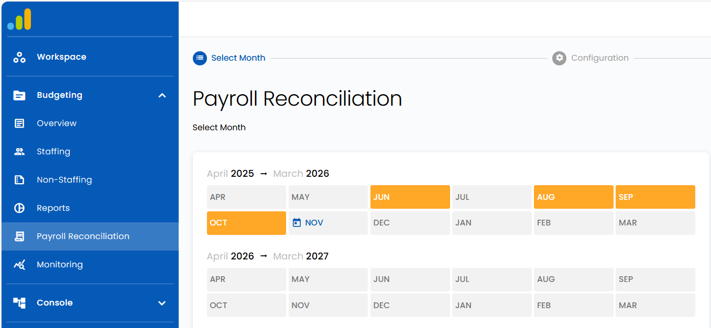
Select the month as required.
Eg if you are importing the November 25 EPM Payroll costing report to check, please click on the Nov box in the section called April 2025 to March 2026 (the year it is in)
Check November 2025 appears in the right or below
Then click on the Import actuals:
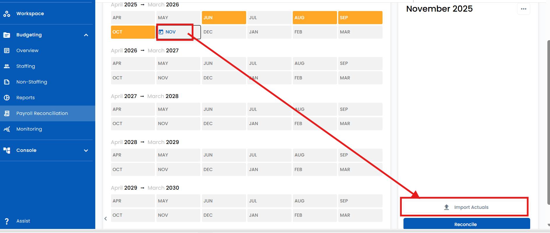
Select the payroll file by clicking to the right of the paper clip and click continue
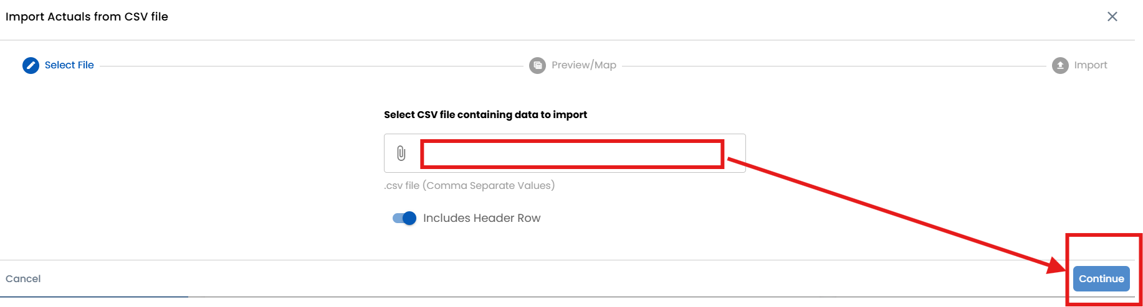
If the header row matches the field required, it will be shown in bold, if not a ‘not mapped’ will show.
If ‘not mapped' appears click on the fields to show a drop down and map accordingly. As above, the three fields required are Employee number, Payroll code and Actual. You do not need to map the other columns.
Click Import, a confirmation message will show the number of lines, check this to the previously notes number of rows, this should be 1 less than you noted as SBS does not include the column header row, if ok, click import when ready.
Message will show any errors or if import is successful, click done to close.
If there are error messages, please screen shot them, and send this plus the file you are trying to import to Sam’s SBS queries email address: sbsqueries@cambridgeshire.gov.uk
When imported the month you have imported in will be orange
Click on this month, then click on Reconcile

What does the Reconciliation tab show?
The expected column is from the budget selected in the top right & the information entered in the Budgeting> staff contracts tab.
The Actuals column is per your imported file

Red Flag – This means the employee number is not matched, add into the system as required and page will update. It could also be that a Payroll Code doesn’t have a service term linked to it. Please ask SBS Queries to check. To do this they will need to know what the payroll code is.
A red flag can also appear when an employee has 2 contracts, but the contract name if the same for both. These need to be named differently (e.g. Admin Sch, Admin Pre Sch).
Red exclamation point – This shows the variance between the expected and actual is above tolerance. This could be due to many things - such as being budgeted on the wrong scale point, FTE, allowance value in SBS incorrect, payroll made a mistake, etc.
Green tick - This shows the variance between the expected and actual is below tolerance.

Re your payroll rec, where staff have multiple contracts but for those contracts the payroll code that they are imported with has the same service term linked to each contract, the system gets confused, so in this case, shows all the actuals added together against one of the contracts. SBS are aware of this and is working on a solution.

If you identified a contract change needed, please remember when changing contract info this only changes in the budget you are in (in the top right), if you have multiple live budgets or are working in a payroll rec budget, please amend the other live budgets too if the change is applicable to them.

Examples of variances & what needs to be done regarding these
- If there is a variance on a particular employee row and this row has an expected amount & an actual amount – click here for information on what to check etc
- Employee listed without name and no expected amount – Click here for information on what to check etc
- If there is a variance on an employee row with an employee number and name with an expected amount without an actual– Click here for information on what to check etc

If there is a variance on a particular employee row and this row has an expected amount & an actual amount
The first thing to check is that the basic pay is correct.
If correct, this will give you a more accurate indication of the difference you need to account for.
If it is not correct, investigate with EPM portal, costings report and SBS contract and update as necessary.

Differences with Basic Pay could be for one of these reasons:
- Employee has reached 5, 10 or 15 years anniversary and therefore qualifies for additional holiday (weeks per year have changed) – if you use EPM, in reporting, the staff list report will give you how EPM have calculated this in column BE.
- Employee has reached 6 months and pay has incremented
- Employee's pay rate (grade) or hours have been amended & SBS needs to be updated, or your payroll provider should have been contacted if budget is correct
- In April, employees on a scale will automatically increment, budget should reflect this but may not
- Employee is on maternity leave- SBS and EPM do not calculate in the same way. Contact your school’s financial advisor for more help on this.
- They may have an allowance that is showing as the wrong amount. Please check what the contract has against it via Budgeting>Staffing>Staff Contracts> Salary Tab> Allowances column.
Allowances names may not be the amount paying, as we have previously set this up as first paid, but they may have since been amended due to pay rises etc, for latest amounts please check the Budgeting>Staffing? Allowances tab>find the allowance listed in the staff contracts tab> check the amount shown in the Rate drop down (the effective date in this financial year). If it is not correct, please email SBS Queries, tell me how the allowance is currently showing, what it should be, if it should be pro-rata’d, if it should have pension, if it should have inflation settings turned on, what date this rate should be used from and Sam will make the necessary adjustments.

Once basic pay is correct you will have a more accurate idea of why the difference has occurred and what this could be. Examples:
Employee has worked additional hours – if you use EPM this will be shown in the addition’s column (the one next to the basic pay column). As you import the total cost including NI & Pension, you will need to work out what the additions plus NI & Pension will roughly be, to check if the variance is due to this fully or partially. Contact Sam Walker via the SBS Queries email address if you are unsure how to calculate this.
They may have opted out of their pension. If they have but the expected amount shows a pension amount, please go to Budgeting>staffing>staff contracts>select the contract>click on salary tab>de-toggle the ERs Pension toggle (make it grey)>press update> then press save and close
Employee may have left or started during the month. Check this, and if contract needs to be amended, please do this in the staff contracts tab, please press save and close after making the amendments.
Employee's contract may have been amended part way through the month. Show these changes by clicking on the contract>salaries tab>add new>change effective date etc> update>press save and close
Maternity, paternity, sick leave – this can be added to the staff members tab, however, please speak to your financial advisor re the best way to show this
(non-exhaustive list)
If you identified a contract change needed, please remember when changing contract info this only changes in the budget you are in (in the top right), if you have multiple live budgets, please amend these too if the change is applicable to them.
Employee listed without name and expected amount, e.g.
This means they may be a new member of staff, that hasn’t been added to the Budgeting>Staffing>Staff Members tab & they haven’t been assigned to a contract.
Search their name, if they do not appear, you will need to add them, do this by clicking on Add:
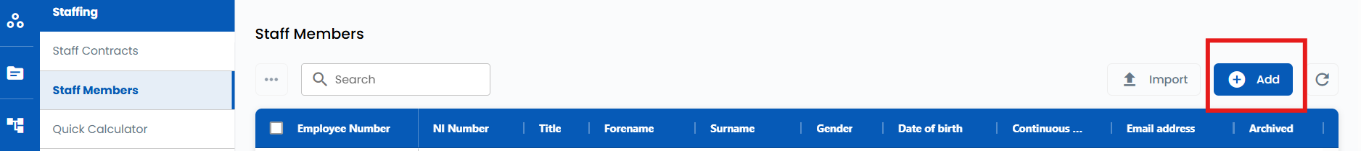
Enter all details
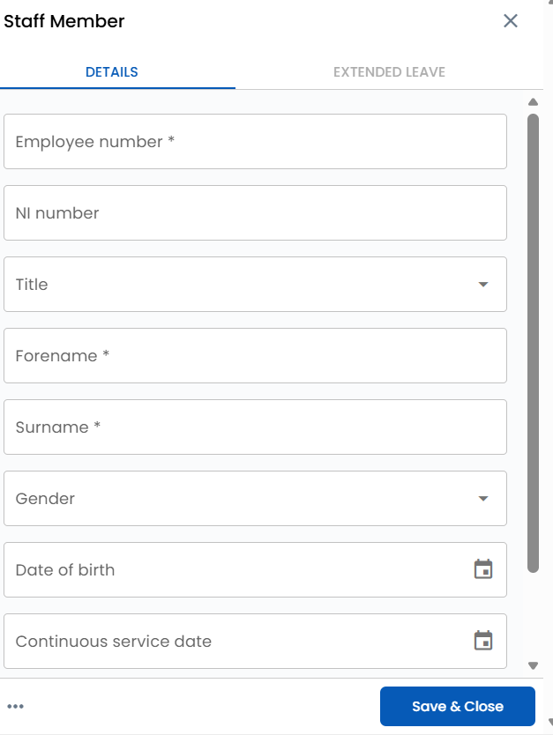
Then click Save & Close.
You now need to go into Budgeting>Staffing>Staff Contracts and assign them to a contract.
This will then mean your imported actuals on your payroll rec can then be matched to the contract they are assigned to.
Go to the Budgeting>Payroll Rec> Month you are checking>reconcile and check.
If the employee now has an expected and actual amount but shows a variance click here to find out what to check

If there is a variance on an employee row with an employee number and name and an expected amount without an actual
- This might mean, that the employee number entered in SBS >Budgeting>Staffing>Staff Members may have some digits or letters missing from their employee number compared to what is shown on the EPM/Payroll provider report.
The EPM reports Employee number column may need to be widened to see the full number.
If this is the case, they may have 2 rows on the reconciliation screen, if paid and has been budgeted for previously but with a different member of staff assigned to the contract
To check if employee number has or hasn’t been entered correctly on SBS enter the staff name in the search box of Budgeting>Staffing>Staff Members> press enter/return & check
If the Employee number has been entered incorrectly, please click on the row that needs to be amended, then type in the missing digits/letters & save and close
Check the Payroll rec now shows correctly with actuals and expected.
If there is a variance then between expected and actuals please investigate, click here for more info on how to do this

- It could be due to an employee not starting in post when expected. Please look into and if this is the case, decide if your forecast needs to be amended accordingly, e.g. Does start date need amending, have you forecasted correctly for cover if this is in the future etc.

To remove a previously imported payroll file, select the month you would like to remove, then click on the 3 dots.
For example, if you wanted to remove November 25’s Payroll import, click on Nov in the year block it relates to, then click on the 3 dots
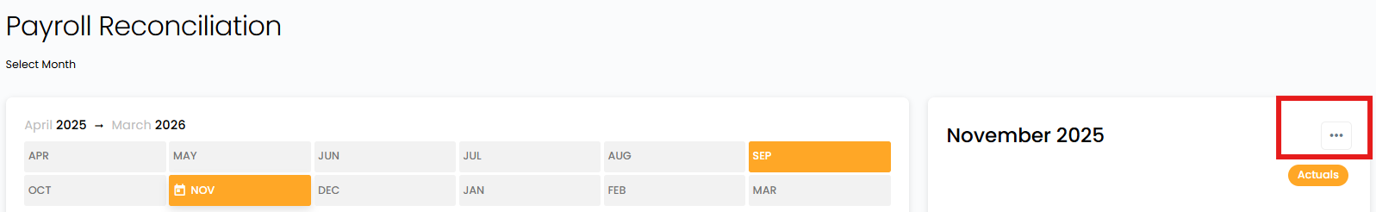
This would appear
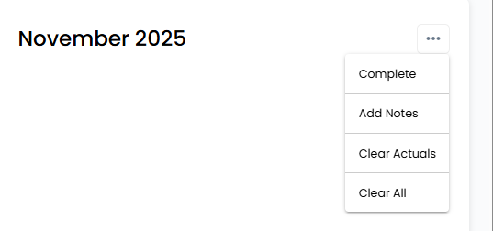
- Complete – This updates the highlighted colour to green and shows as complete.
- Add notes – Add notes to the month and year if required to be shown in that box.
- Clear Actuals – Clear only actual values from the month and year. (this leaves notes and adjustments made when reconciling) – UNFORTUNATELY THIS ISNT WORKING PROPERLY AT THE MOMENT BECAUSE WHEN IT IS PRESSED IT DOESN’T ALLOW YOU TO IMPORT AGAIN, FOR NOW PLEASE SELECT CLEAR ALL, UNTIL THE FIX COMES IN.
- Clear All – Clears all actuals, notes and adjustments made when reconciling.
If you accidentally press Clear Actuals, it will remove the option to re import. This is ok, press clear all & it then gives you the option to re-import

