Hiding Budgets on SBS

To show fewer budgets in the drop down lists within SBS, there is an option to hide your budgets.
Please do not delete them.
If you hide budgets these would still remain in the Console>Budgets> Management list and can be unhidden as needed.

If you would like to hide your budgets, please follow the steps below:

Go to Console>Budgets> Management> Search School Name> Click on Budget you would like to hide> Edit Budget> Click Hidden in this section:
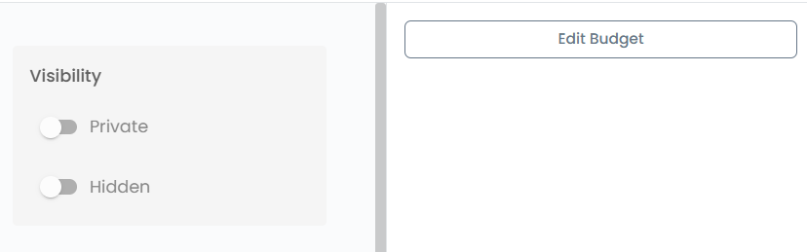
Then press Save Budget.

If you then at any point want to unhide your hidden budgets, you would just need to go into Console>Budgets> Management> Search School Name> Click on Budget you would like to hide> Edit Budget> untoggle your hidden budget. You can then view everything like they had never hidden it.

