Please check you are using the correct Extended Leave tables in all your live/current budgets.
(If you haven’t locked your 25/26 Governor Approved budgets DO NOT change these please, these budgets need to remain as you submitted them)
Your current/live 25/26 budgets should have the Extended Leave Table set as:
How to check if your budgets are showing the correct Extended Leave table
In the top right corner of SBS, select the budget you need to check from the drop down for example:
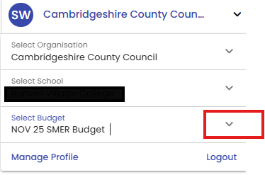
Click on the workspace tile:
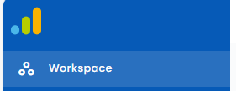
Go to Budgeting>Overview>Core Settings tab
In the Extended Leave Tables section it should show as this:
If it doesn’t, please go to:
Console>Budgets>Management>Search School Name> click on the budget you would like to change> click on edit budget>go to Extended leave tables section on the Core Settings tab>click on the + symbol
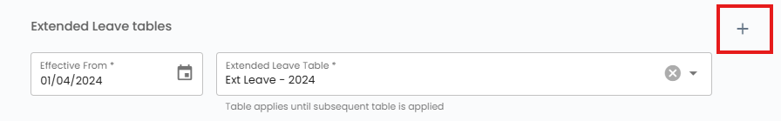
Check the correct Effective from date appears> then from the drop down menu select Ext Leave – 2025
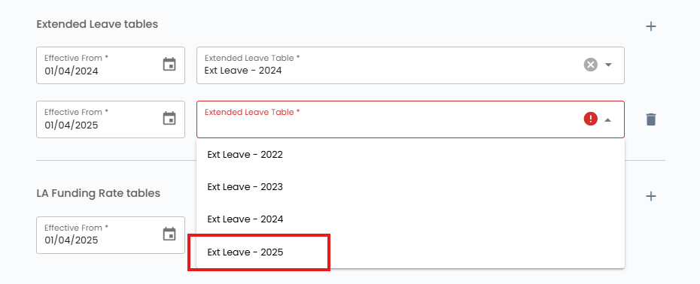
Then press Save Budget
Repeat this for all live/current budgets (budget scenarios).

