Actions required by School to successfully apply the new Pay Scales

To ensure that the new scales feed through correctly, you will need to follow these short steps to every budget that you intend to rely on for 2025/26 budget planning. These steps are crucial to ensure that the new scales feed through and should not be ignored.

These changes should **not** be applied to any Payroll Reconciliation budgets that you use or to the 25/26 Governor Approved budget.

The 25/26 Governor Approved budgets should be as your Governors approved your budget including the 3% inflations for 25/26.

1. Log into SBS and navigate to the “Console”

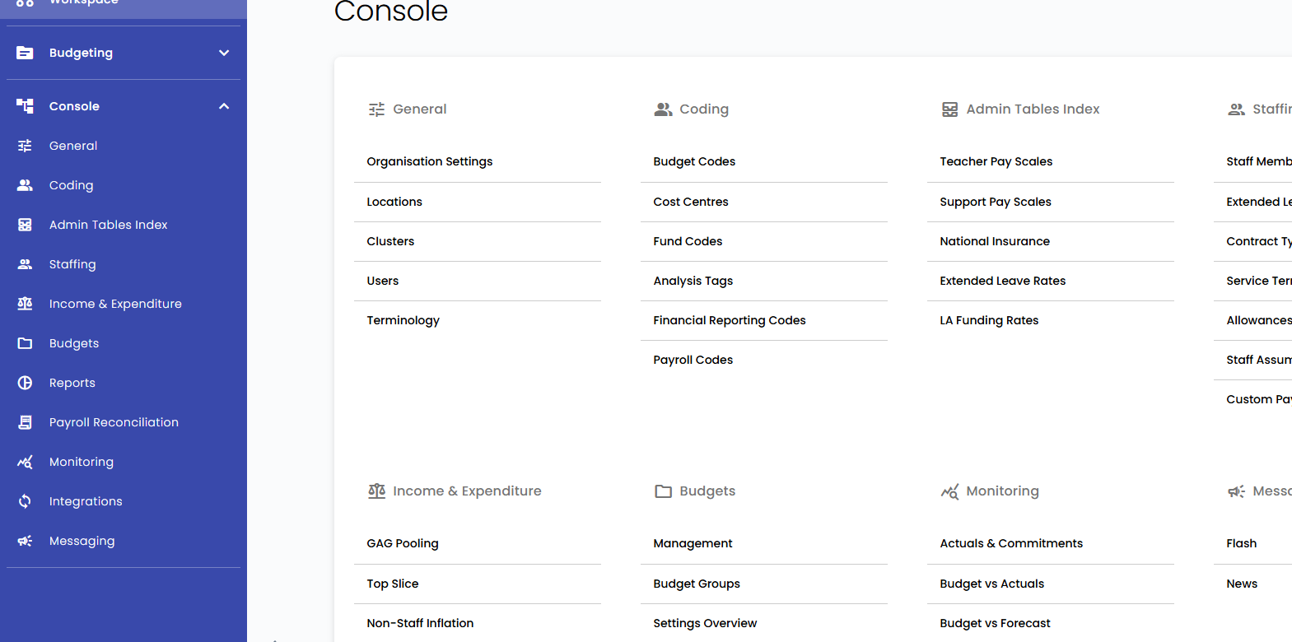

1. Click “Management” under the Budgets header

1. Find the budget that you wish to apply the new pay scales to from the list. Click the budget name
2. Navigate to the “Assumptions” tab

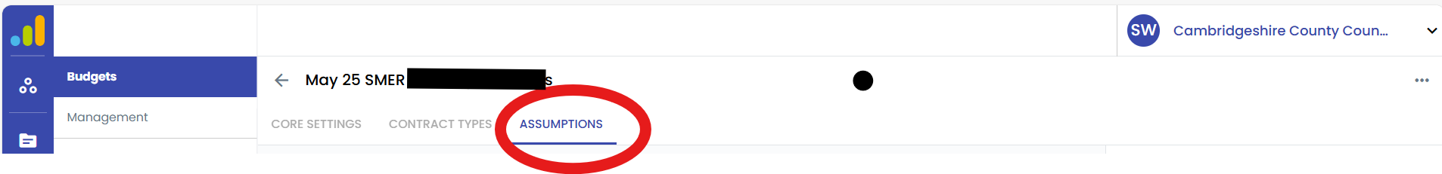

1. Click Edit Budget

1. You should check that your set up for each pay table looks as follows
   1. For Teachers Pay Scales

To add the 01/09/2025 pay scale table click on the add button, as shown below:

* 1. For Support Pay Scales

Please show as per the below.

The support staff pay award has not yet been approved. Please do not amend the Support Staff Pay Scale. Once the pay award for support staff has been agreed, we will issue further guidance to schools

* 1. For Custom Scales

* 1. For Staff Assumptions



1. Once you have checked and updated where necessary to mirror the set up above, click “Save Budget”

**\*Please note, you must click “Edit Budget” and “Save Budget” even if your assumption tables match as outlined above and no changes are required.**

1. You should repeat these steps in each budget you intend to rely on for 2025-26 budget forecasting.