Actions required by School to successfully apply the new Pay Scales for Support Staff

The NJC Pay award was agreed on 23rd July 2025 at 3.2% on all points from 01/04/2025.

SBS have added the pay scale Support - 2025 to SBS which includes the 3.2%.

To ensure that the new support staff scales feed through correctly, you will need to follow these short steps to every budget that you intend to use for forecasting this years financial position. These steps are crucial to ensure that the new approved support scale feeds through and should not be ignored.

These changes should **not** be applied to any Payroll Reconciliation budgets that you use until the new rates have been paid or to the 25/26 Governor Approved budget.

The 25/26 Governor Approved budgets should be as your Governors approved your budget including the 3% inflations for 25/26.

1. Log into SBS and navigate to the “Console”

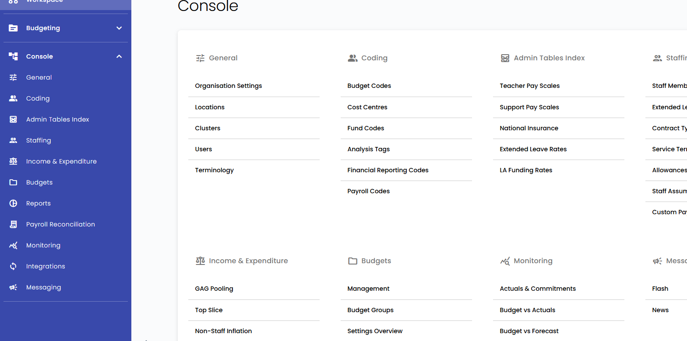

1. Click “Management” under the Budgets header

1. Find the budget that you wish to apply the new support pay scale to from the list. Click the budget name
2. Navigate to the “Assumptions” tab

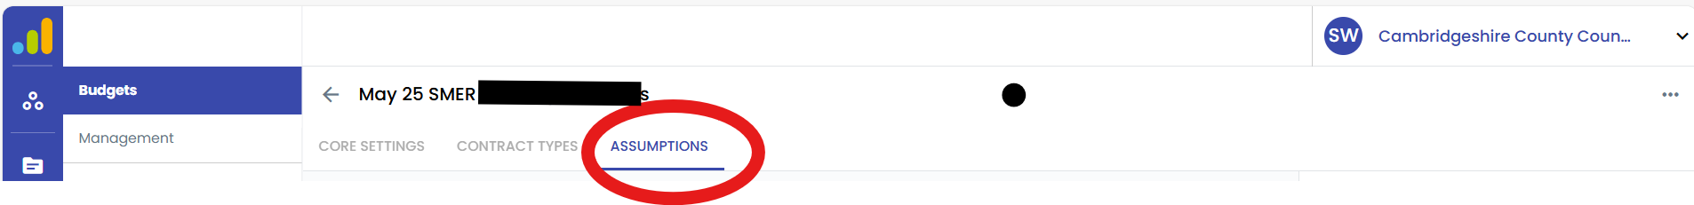

1. Click Edit Budget

You should check that your set up for each pay table looks as follows

* 1. For Teachers Pay Scales

* 1. For Support Pay Scales

Please show as per the below.

1. For Custom Scales

1. For Staff Assumptions



If you use Custom Support Scales, please let us know which Scale Points should be amended, what they are currently showing as & what they should be amended to and I will amend them.

1. Once you have checked and updated where necessary to mirror the set up above, click “Save Budget”

**\*Please note, you must click “Edit Budget” and “Save Budget” even if your assumption tables match as outlined above and no changes are required.**

1. You should repeat these steps in each budget you intend to rely on to forecast your 25/26 financial position.