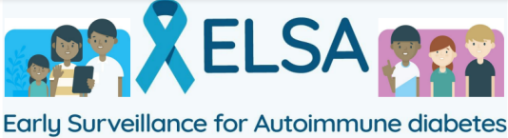

Your school is invited to take part in the ELSA study
The ELSA study is screening children and young people (age 2-17) across the UK to identify those at risk of developing Type 1 diabetes. We are currently inviting secondary schools to host clinics during the academic year 26/27.
Around 3 in every 1,000 children and young people are at high risk of developing Type 1 diabetes. The only way to identify those at risk is through screening.
For those identified as higher risk, we can offer support, education, and monitoring for children and their families.
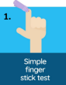
The screening test is a simple finger-prick blood test¹.
This can take place at home, in school or in an NHS setting, and is sent back to the ELSA team for testing. For more information, please visit: https://www.elsadiabetes.nhs.uk
What will happen if my school decides to take part?
- We will arrange an ELSA clinic in school from Autumn 2026
- A trained team of nurses and health care staff will visit to carry out the finger-prick test
- Only pupils with parent or guardian consent (or young people over 16) will take part
- Families and young people will provide consent online
- There is funding provided to schools who host an ELSA clinic (£300)
We ask schools to:
- Share study information with pupils and families
- Provide a member of staff to support on the day of the clinic
For more information or to register your school’s interest please contact:
East of England Community Health and Care NHS Trust
Email: eec.gen-cambs-researchhub@nhs.net

