

**Professional Development and Improvement Adviser**

**Instructor for Adult Mental Health First Aid**

[**Juliet.Adloune@cambridgeshire.gov.uk**](mailto:Juliet.Adloune@cambridgeshire.gov.uk)

**Juliet Adloune**

Dear Parent/s and Carer/s

Supporting the learning of your children at home during these unprecedented times can be very challenging. You have not become a qualified teacher overnight! Most of you have not chosen to home educate your children. Using the resources provided by the school in a way which suits the rhythm of the whole household will be completely different for us all.

I just wanted to share one way of helping yourself to help your child/rem. This idea is genuinely just an idea. It has been inspired by the requests and messages I have received from parents/carers asking for support with managing this aspect of the current situation, alongside all their other commitments. I offer this suggestion with the mental health/well being of ALL in mind (parents/carers and children) alongside my expertise in Primary Education.

Supportive words and encouragement have a vital role in how we feel. So do actual, practical ideas.

The template and example gives you a framework and could be so easily adapted. Use post-its or blue-tacked paper to make changes each day. Do note the rather repetitive use of 'sometimes' in the steps below…that's because some times are different to others!

1. Agree the task under each heading (either the night before or first thing). Sometimes only 3 of the sections are used. Sometimes the task set by school is cut down. Sometimes complete tasks are omitted.
2. The child chooses the order in which tasks are completed. Some are independent, some supported. Sometimes this has to fit the work schedule of the adult at home or the needs of other family members. Sometimes expectation/deadlines are set based on regular breaks, free choice activities, downtime and other treats.

Be kind to yourself.

Ask for help.

You can only do what you can do.

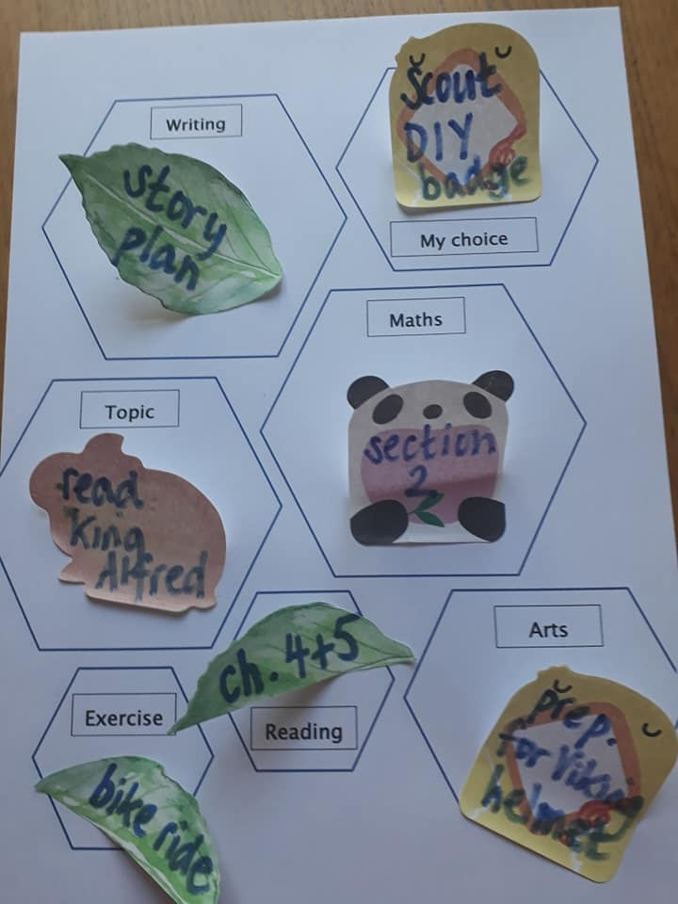

**Writing**

**Maths**

**My choice**

**Arts**

**Reading**

**Exercise**

**Topic**