Agenda Item No: 5

GROWTH FUND

To: Peterborough Schools’ Forum

Date: 13th July 2022

From: Jonathan Lewis – Director of Education

1.0 | Introduction
1.1 | This paper provides an update of the allocation of the growth fund following Schools Forum approval of the growth criteria and centrally retained amount in January’s forum
2.0  2.1 | Growth allocations supporting anticipated growth for Autumn term 2022  The table below details the updated school/academy allocations  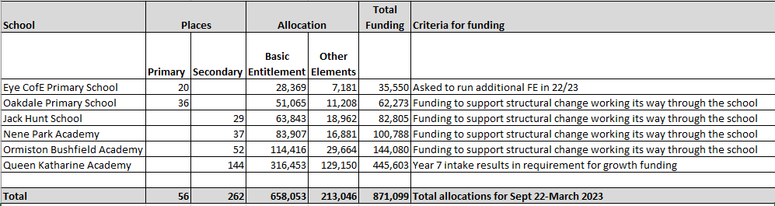
3.0  3.1 | Pre-opening funding  An allocation has been set aside for the new maintained school, St John Henry Newman, due to open in September 2022. The funding available is the balance of the £50k pre-opening funding of £37.5k and dis-economies funding to allow the school to put in place the required management structures and to meet the resourcing costs of new year groups of £47.7k
4.0  4.1 | Balance on Growth Fund 22-23  Based on current allocations of growth funding and new school funding the growth fund is currently in surplus which allows for changes in final admissions and any other schools who may qualify  Growth Fund 22-23 £  Total Growth Fund agreed Jan forum 1,200,000  Total allocations for school places (871,099)  New school allocation (85,200)  Total surplus 243,701

