Agenda Item No: 3

Schools Financial Health – Revenue Balances and Balance Control Mechanism

To: Peterborough Schools’ Forum

Date: 13th July 2022

From: Jonathan Lewis – Director of Education

1.0 | Introduction
1.1 | This paper provides Schools Forum with an analysis of maintained schools revenue accounts for the financial year 2021-22 and a summary of academy balances for the academic year 20-21
2.0  2.1 | 2021-22 Maintained Schools Revenue Balances  The table below details the 2021-22 year-end revenue balances by phase and makes comparisons to 2020-21. The figures exclude balances relating to community focused activities and cluster funding.
Phase | No of Schools | Balances 31st March 2021 £ | Balances  31st March 2022 £ | Change | % Change
Nursery | 1 | 36,029 | 56,858 | 20,829 | 57.81%
Primary | 22 | 2,897,097 | 2,152,417 | -744,680 | -25.70%
Secondary | 2 | 656,028 | 796,233 | 140,205 | 21.37%
Special | 3 | 792,219 | 590,674 | -201,545 | -25.44%
Total | 28 | 4,381,373 | 3,596,182 | -785,191 | -17.92%

Overall revenue balances have increased across nursery/secondary schools but decreased across primary/special schools. The balances in 20/21 were higher than usual due to there being no balance control mechanism in place as result of the uncertainty around Covid and the closure/partial closure of schools.

The previous year end balances have been adjusted to include only maintained schools at the end of March 2022. Academy convertors since April 2021 have been removed in order to give a like for like comparison.

Appendix A at the end of the report details at school level the revenue balances at 31st March 2022 and as a % of the schools delegated budget share.

The table below shows the banded level of balances as a % of the delegated budget share by phase

Balance as % of budget share
Phase | -1% | 0% | 2% | 3% | 4% | 5% | 6% | 7% | 8% | 9% | 10% | 16% | Total
Nursery |  |  |  |  |  |  |  |  |  | 1 |  |  | 1
Primary | 1 | 1 | 1 | 3 | 2 | 4 | 4 | 1 | 3 |  | 1 | 1 | 22
Secondary |  |  |  |  |  |  | 1 | 1 |  |  |  |  | 2
Special |  |  |  |  |  | 1 |  |  | 2 |  |  |  | 3
Total | 1 | 1 | 1 | 3 | 2 | 5 | 5 | 2 | 5 | 1 | 1 | 1 | 28

The graph below shows the change in current maintained schools balances over the last 5 financial years:

3.0  3.1 | Peterborough Academy Balances  The table below details the 2020-21 academic year revenue balances by phase for Peterborough’s Academy schools and makes comparisons to the 2019-20 academic year.  Appendix B shows the Academy balances at school level
  Phase | No of Academy Schools | Balances  31st August 2020 £ | Balances  31st August 2021 £ | Change | % change
  Primary | 36 | 9,677,248 | 7,429,470 | -2,247,778 | -23.23%
  Secondary | 9 | 6,454,437 | 5,203,805 | -1,250,632 | -19.38%
  All-through | 3 | 4,768,724 | 6,072,038 | 1,303,314 | 27.33%
  Special | 2 | 823,000 | 551,000 | -272,000 | -33.05%
  PRU | 1 | -41,000 | -228,000 | -187,000 | 456.10%
  Total | 51 | 21,682,409 | 19,028,313 | -2,654,096 | -12.24%
4.0  4.1 | Revenue Income and Expenditure Per Pupil (Maintained Schools)  Each year maintained schools are required to submit their year-end accounts in a format called Consistent Financial Reporting (CFR). The table below provides a summary of key areas of income and expenditure for 2020/21 and 2021/22. School level figures are detailed in Appendix C (spreadsheet attachment). The figures are based on the following:  - Per pupil allocations/costs are averages for the sector  - FTE for 2020/21 are based on 5/12ths of Jan 20 census numbers and 7/12ths of Jan 21 census numbers  - FTE for 2021/22 are based on 5/12ths of Jan 21 census numbers and 7/12ths of Jan 22 census numbers  - Schools block and 6th form funding include delegated funds (I01), sixth form funding (I02), high needs funding (I03) and EAL funding (I04)  - Grant funding includes pupil premium (I05), government grants (I06), other grants and income (I07) and additional grants including covid catch up grants and PE sports grant (I18)  - Teachers costs include contracted teachers (E01), supply (E02) and agency (E26)  - Other staff cost include premise staff (E04), admin and clerical staff (E05), catering staff (E06) and cost of other staff (E07)  - Learning Resources include Curriculum Costs (E19) and ICT learning resources (E20)
Primary (including nursery) Income/Expenditure | 2020/21 | 2021/22 | Change | % Change
Schools Block & 6th form funding per pupil | 6,456.58 | 6,550.04 | 93.46 | 1%
Grant Funding per pupil | 714.68 | 758.47 | 43.79 | 6%
Teacher costs per pupil | 3,397.96 | 3,619.30 | 221.34 | 7%
Education support staff costs per pupil | 1,646.71 | 1,684.31 | 37.60 | 2%
Other staff costs per pupil | 816.27 | 849.90 | 33.62 | 4%
Learning resources costs per pupil | 253.06 | 368.65 | 115.59 | 46%
Energy costs per pupil | 84.24 | 94.53 | 10.28 | 12%

Secondary Income/Expenditure | 2020/21 | 2021/22 | Change | % Change
Schools Block & 6th form funding per pupil | 6,389.71 | 6,691.45 | 301.74 | 5%
Grant Funding per pupil | 351.76 | 429.48 | 77.72 | 22%
Teacher costs per pupil | 3,619.01 | 3,758.79 | 139.79 | 4%
Education support staff costs per pupil | 876.97 | 948.74 | 71.77 | 8%
Other staff costs per pupil | 639.27 | 707.03 | 67.76 | 11%
Learning resources costs per pupil | 293.77 | 359.28 | 65.51 | 22%
Energy costs per pupil | 39.82 | 53.26 | 13.44 | 34%

Special Income/Expenditure | 2020/21 | 2021/22 | Change | % Change
Schools Block & 6th form funding per pupil | 6,683.21 | 6,763.35 | 80.13 | 1%
Grant Funding per pupil | 742.77 | 800.86 | 58.09 | 8%
Teacher costs per pupil | 3,706.82 | 3,946.90 | 240.09 | 6%
Education support staff costs per pupil | 1,498.25 | 1,517.27 | 19.03 | 1%
Other staff costs per pupil | 802.87 | 846.61 | 43.74 | 5%
Learning resources costs per pupil | 272.72 | 406.02 | 133.30 | 49%
Energy costs per pupil | 82.21 | 91.50 | 9.28 | 11%

5.0  5.1 | 2021-22 Capital Balances-Maintained Schools  The tables below detail the schools capital balances by phase and funding source. During 2021/22 £1.1m of revenue was transferred from capital to revenue.
  Primary (including nursery) Source of Funding | Opening Balance | Closing Balance | Change | % Change
  Devolved Formula Capital | 104,391 | 85,415 | -18,976 | -18%
  Capital Project Funding | 23,400 | 23,400 | 0 | 0%
  Direct Revenue Financing | 396,482 | 565,365 | 168,883 | 43%
  Other Capital | 15,040 | 691 | -14,349 | -95%
  Secondary Source of Funding | Opening Balance | Closing Balance | Change | % Change
  Devolved Formula Capital | 28,507 | 6,824 | -21,683 | -76%
  Capital Project Funding | 0 | 0 | 0 | 0%
  Direct Revenue Financing | 0 | 0 | 0 | 0%
  Other Capital | 0 | 20,932 | 20,932 | 100%
  Special Source of Funding | Opening Balance | Closing Balance | Change | % Change
  Devolved Formula Capital | 44,092 | 30,481 | -13,611 | -31%
  Capital Project Funding | 15,629 | 5,719 | -9,910 | -63%
  Direct Revenue Financing | 241,376 | 282,935 | 41,559 | 17%
  Other Capital | 9,620 | 0 | -9,620 | -100%
6.0  6.1  6.2 | Balance Control Mechanism  There is currently no requirement for local authorities to operate a Balance Control Mechanism (BCM). Peterborough, in consultation with Schools Forum, has continued to operate a BCM to ensure funding is spent on those children which generated that funding.  The BCM criteria for 2021-22 was as follows:  - Schools balances cannot exceed 8% of their individual Schools Budget Share (ISB) for primary / special schools and 5% for secondary schools.  - Revenue balances over this threshold will be clawed back  - There will be no distinction between committed and uncommitted balances for the purpose of applying the BCM  - Late funding distributed by the local authority and new in year grants announced by the Government, that the school was unaware of, is deducted from the final revenue balance before applying the BCM calculation  - A panel, consisting of Schools Forum members from the relevant phase, will be established to review any appeals prior to the balances being clawed back
6.3 | Two schools exceeded the 5% / 8% in 2021/22 and will are currently working with them over understanding these surplus balances.
6.4  6.5 | No changes are proposed to the BCM in 2022/23.  Action: Schools Forum are asked to consider the proposals to maintain the current BCM of 8% for 2022/23

Appendix A – Maintained school balances

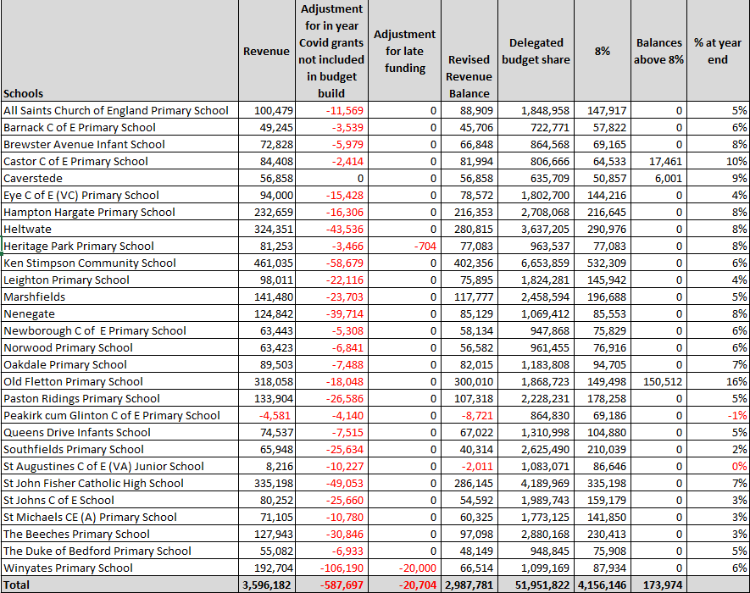

APPENDIX B - Academy School Balances

